**LOGISTIC REGRESSION**

GEOMETRIC INTUITION

SIGMOID FUNCTION SQUASHING

MATHEMATICAL FORMULATION OF OBJECTIVE FUNCTION

WEIGHT VECTOR

L2 REGULARIZATION OVERFITTING AND UNDERFITTING

L1 REGULARIZATION AND SPARSITY

PROBABILISTIC DERIVATION OF LOGISTIC REGRESSION

LOSS MINIMIZATION INTERPRETATION

HYPERPARAMETER SEARCH/OPTIMIZATION

COLUMN / FEATURE STANDARDIZATION

FEATURE IMPORTANCE AND FEATURE INTERPRETABILITY

COLLINEARITY OF FEATURES

# **GEOMETRIC INTUITION**

We need to find the hyperplane which makes the data linearly separable.

Equation of line/ hyperplane $π$: $w^{T}x +b$ = 0

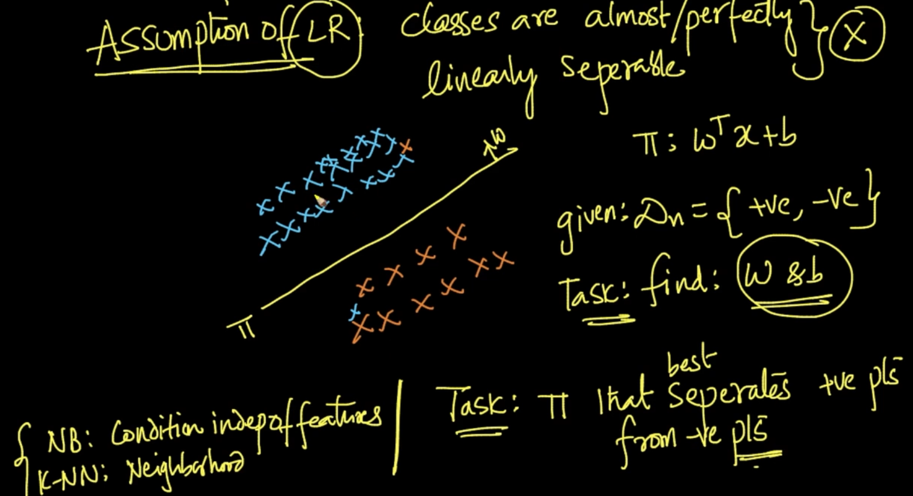

Assumption of Logistic Regression is that our data is perfectly linealrly separable. So, our task is to find the hyper-plane $π$ that seperate both the +ve and -ve points.

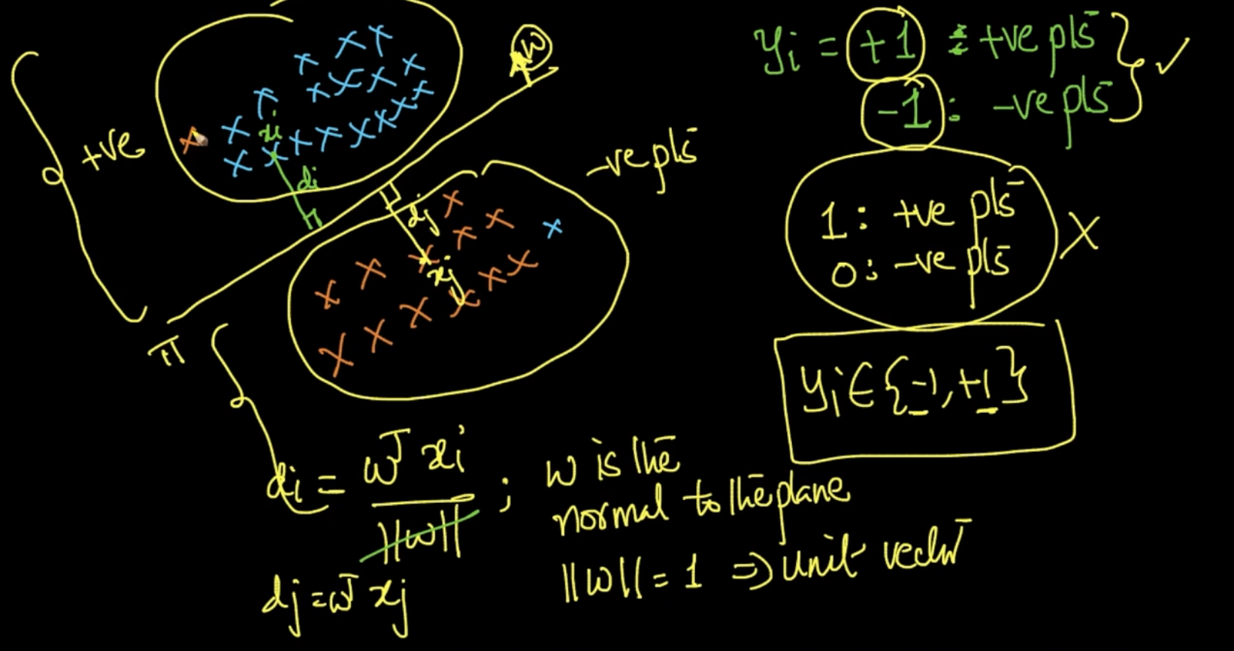

We are calculating distance $d_{i}$ of a point $x_{i}$ which is $d_{i}$ = $w^{T}x_{i}$. We’ve labeled all the blue points as +ve points and the orange ones are -ve points.

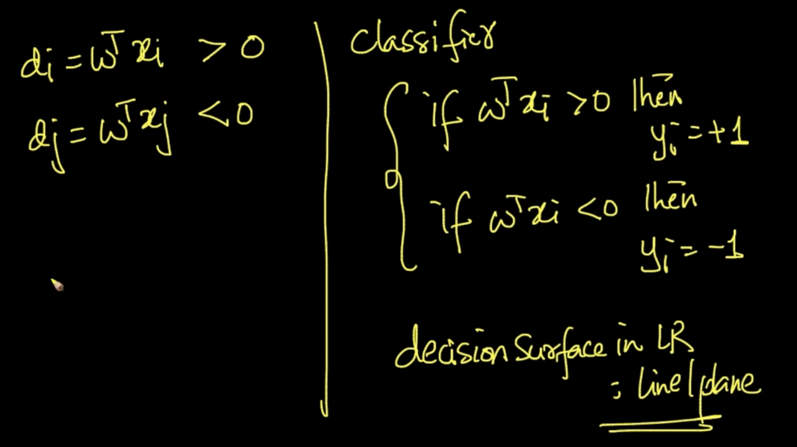

Point $x_{i}$ lies in the +ve region and the direction of normal w is also at +ve points direction

So , $w^{T}x_{i}$ > 0 . Hence we built a classifier saying that *if $w^{T}x_{i}$ > 0 then $y_{i}$ = +1 elif $w^{T}x_{i}$*  < 0 then $y_{i}$ = -1. Thats why we wanted an ideal plane $π$ which is decision surface.

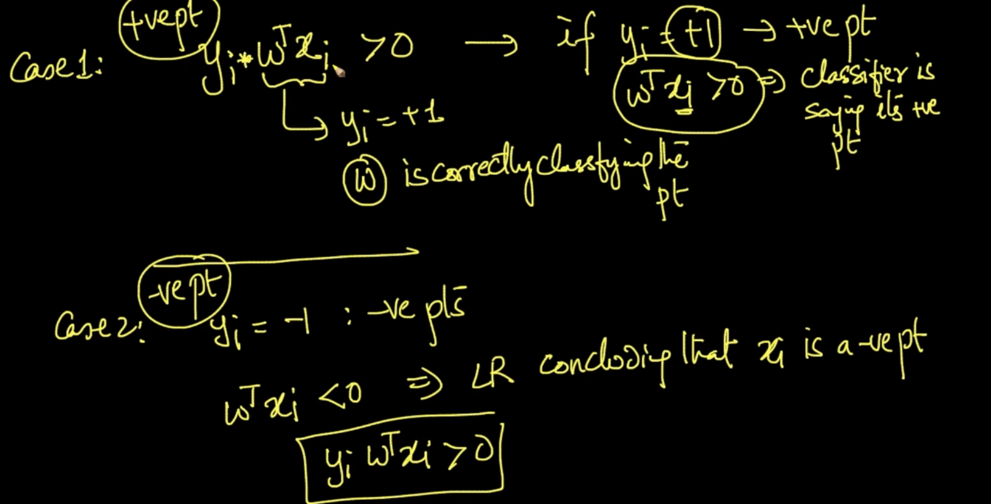

**Case 1** : if $y_{i}$ = +1 and $w^{T}x_{i}$ > 0 then the classifier is saying $x_{i}$ is a +ve point. So, if

$y_{i}*w^{T}x_{i}$ > 0 and $y_{i}$ = +1 then we can say that our normal **w** is correctly classifying the point

**Case 2 :** Same as case 1 except that case 2 is for -ve point . Here also $y_{i}*w^{T}x_{i}$ > 0.

**NOTE** : Both the cases are of **w** correctly classifying data points and in both $y_{i}*w^{T}x_{i}$ **> 0**

So, we want $y_{i}*w^{T}x_{i}$ greater than 0 to make sure that our classifier is working correctly

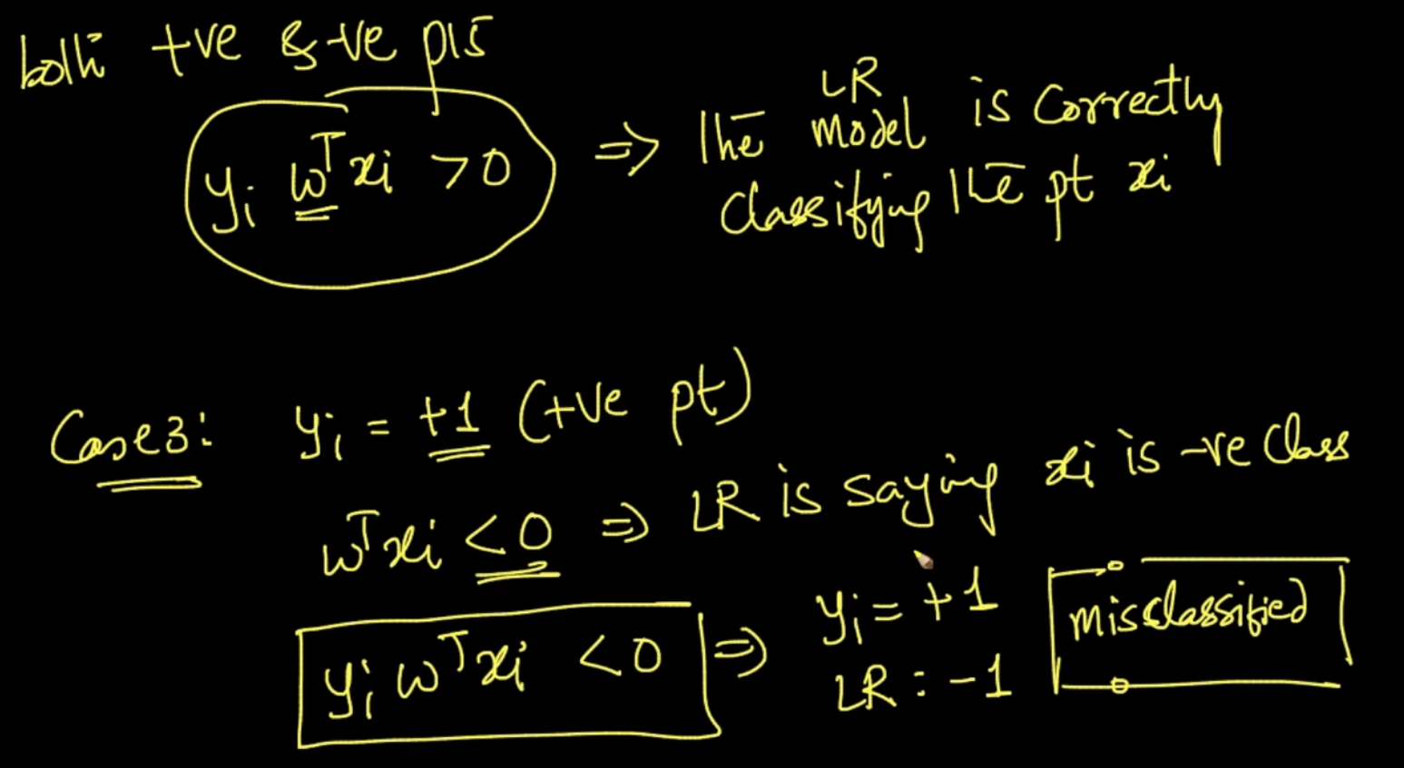

**Case 3 :** Here $y_{i}$ = +ve point but $w^{T}x_{i}$ < 0 so $y_{i}*w^{T}x_{i}$ < 0 that means our Logistic Regression is misclassifying the data as LR : -1. Ex: Blue point in the orange points.

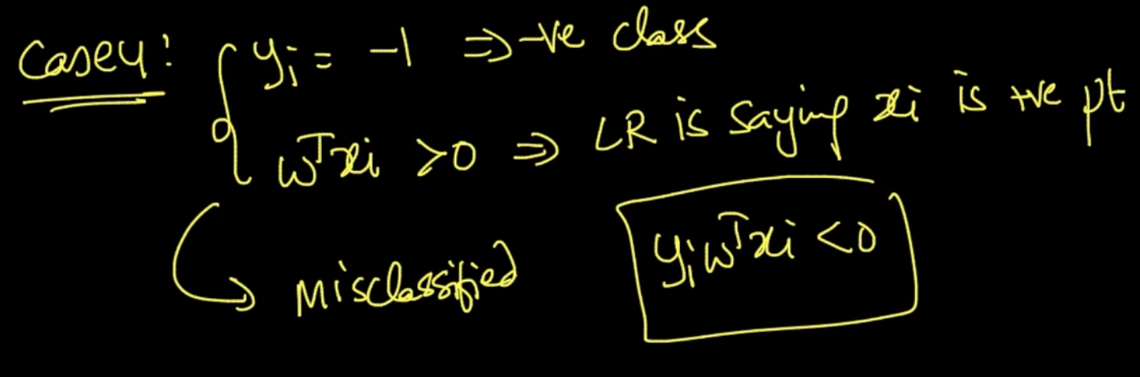

**Case 4:** Same as case 3. Here also $y_{i}*w^{T}x_{i}$ < 0.

**NOTE :**  Case 3 and Case 4 both the cases are of **w** incorrectly classifying data points and in both $y_{i}*w^{T}x_{i}$ **< 0.** So, we want $y_{i}*w^{T}x_{i}$ < 0 points to be less than 0 to make sure that our classifier is working correctly.

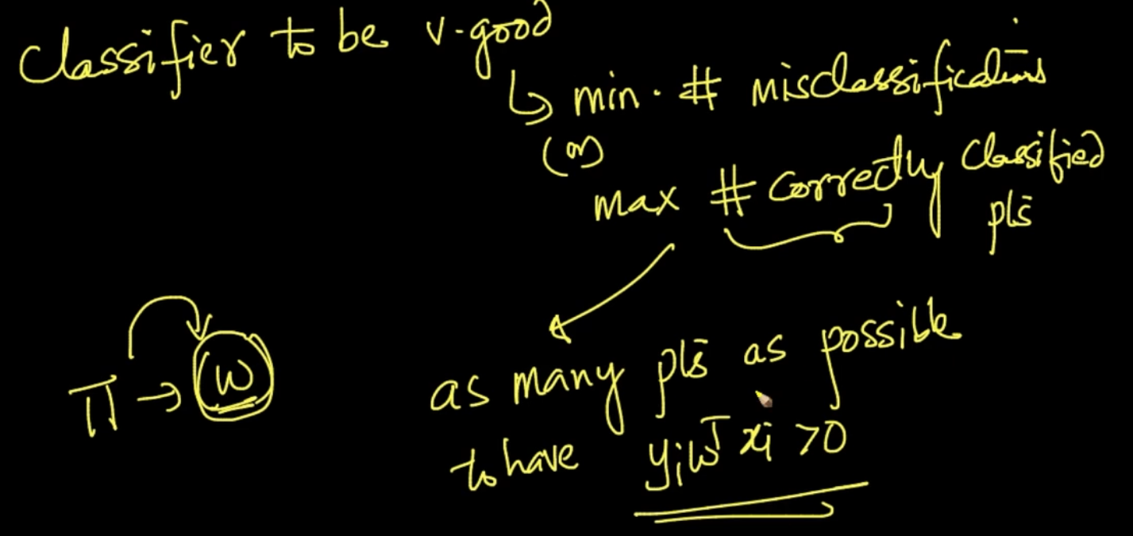

So in order for our classifier to be good we want as many points as possible to have

$y_{i}*w^{T}x_{i}$**> 0**

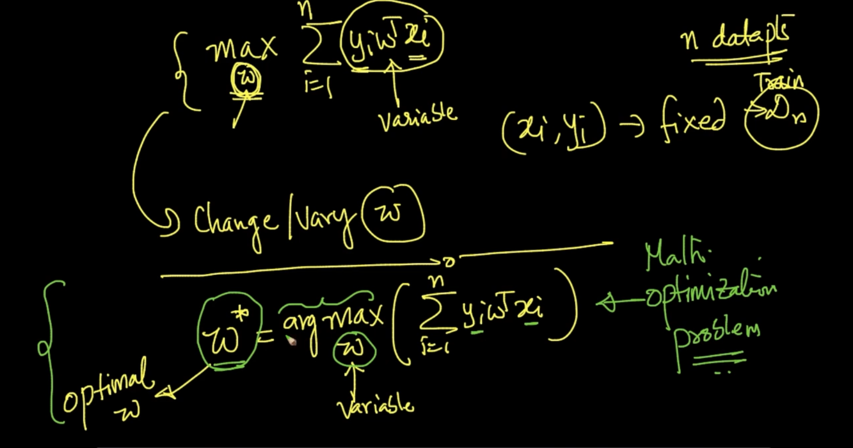

In this our $x_{i}$ and $y_{i}$ are fixed so the only thing that can be varied in $y_{i}*w^{T}x_{i}$ is $w^{T}$.

So, our goal is to find the optimal w => $w^{*}$ which gives us maximum in summation of $y_{i}*w^{T}x_{i}$ as more $y_{i}*w^{T}x_{i}$ > 0 means more correctly classified data. Our maximum of summation gives that . So finding this optimal w is the crux of this algorithm called Logistic Regression

# **SIGMOID FUNCTION SQUASHING**

We need to find the optimal w -> $w^{*}$ 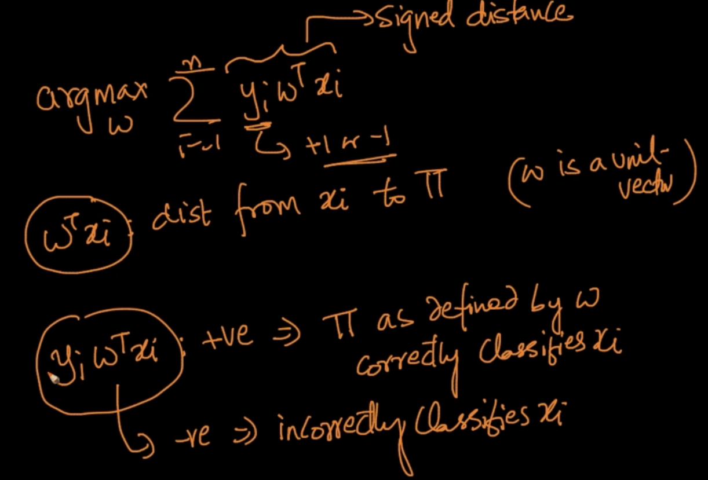

y gives us sign of the point +1 or -1. $w^{T}x_{i}$ is the distance of data point $x_{i}$ from plane $π$

If $y_{i}w^{T}x_{i}$: +ve then our $π$ defined by w correctly classifies $x_{i}$. So we want it to be maxed

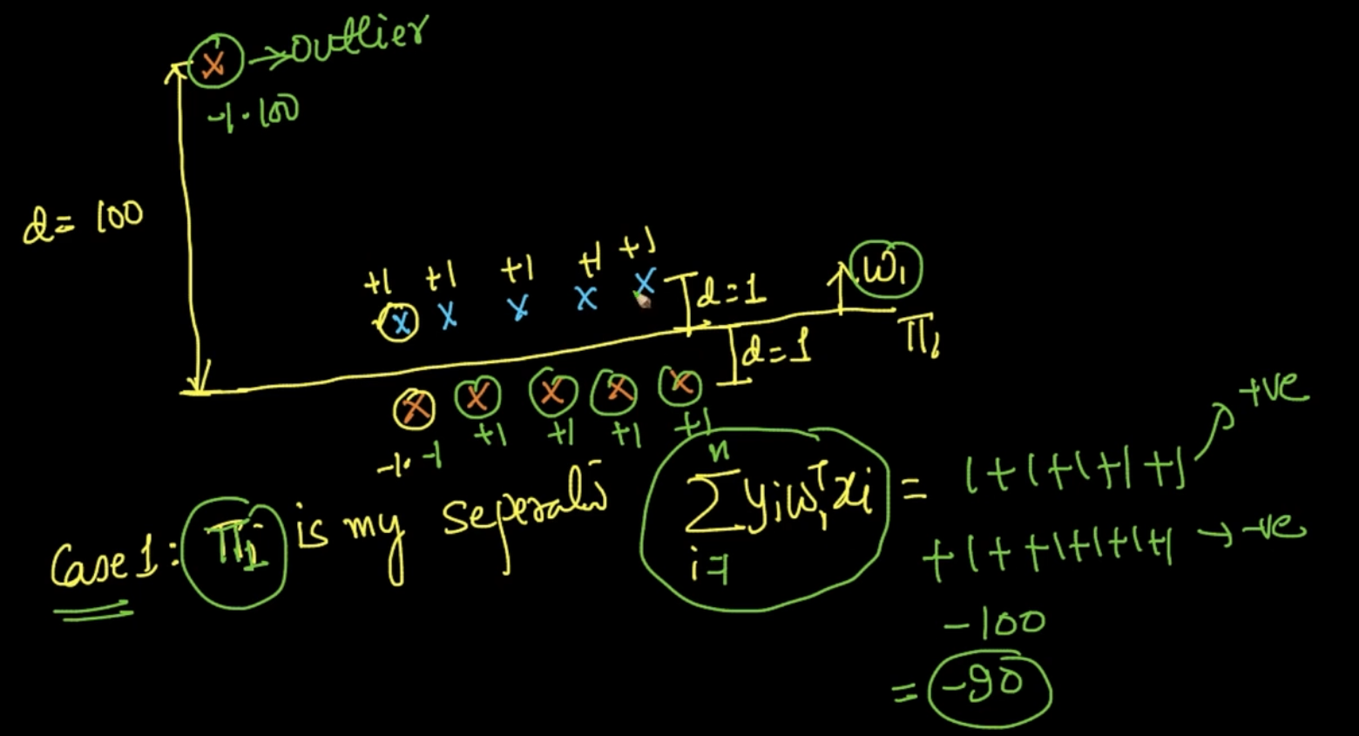

Case 1: Here for +ve points(blue) distance d => $w^{T}x$ = 1 and y = +1 since positive

Here for -ve points(orange) distance d => $w^{T}x$ = -1 since opposite to direction of w and

y = -1 since negative. For the outlier d = +100 since in the direction of w and -ve point

Therefore y = -1. $\sum_{i = 1}^{n}{}y_{i}w^{T}x_{i}$ = -90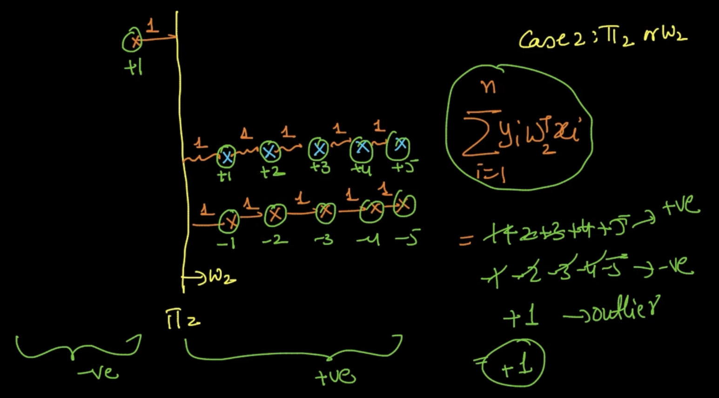

Case 2: Here the plane is separating the outlier and points. Here $\sum_{i = 1}^{n}{}y_{i}w^{T}x_{i}$ = +1

We want $\sum_{i = 1}^{n}{}y_{i}w^{T}x_{i}$ to be maxed so our model will say Case 2 but we know intuitively that the plane in Case 2 is doing a shit job as it’s misclassifying more data. It’s happening because of our outlier . So our max $\sum_{i = 1}^{n}{}y_{i}w^{T}x_{i}$ isn’t prone to outliers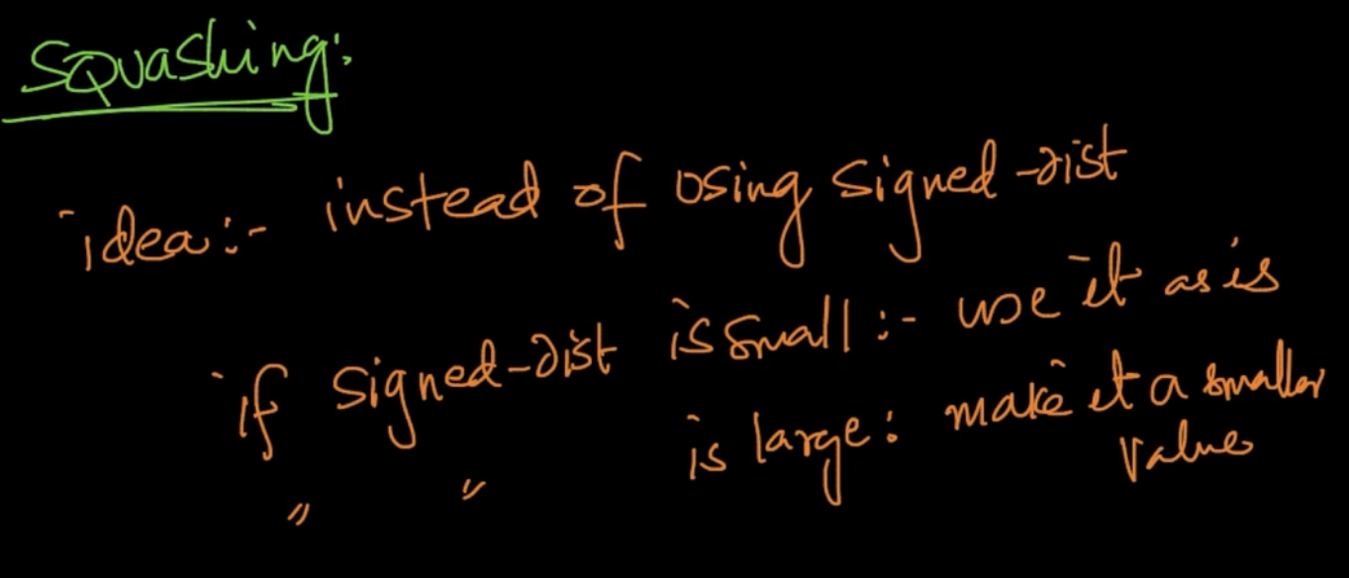

So to deal with it we do squashing. It means if the distance is small use it as it is but if it’s large make it a smaller value

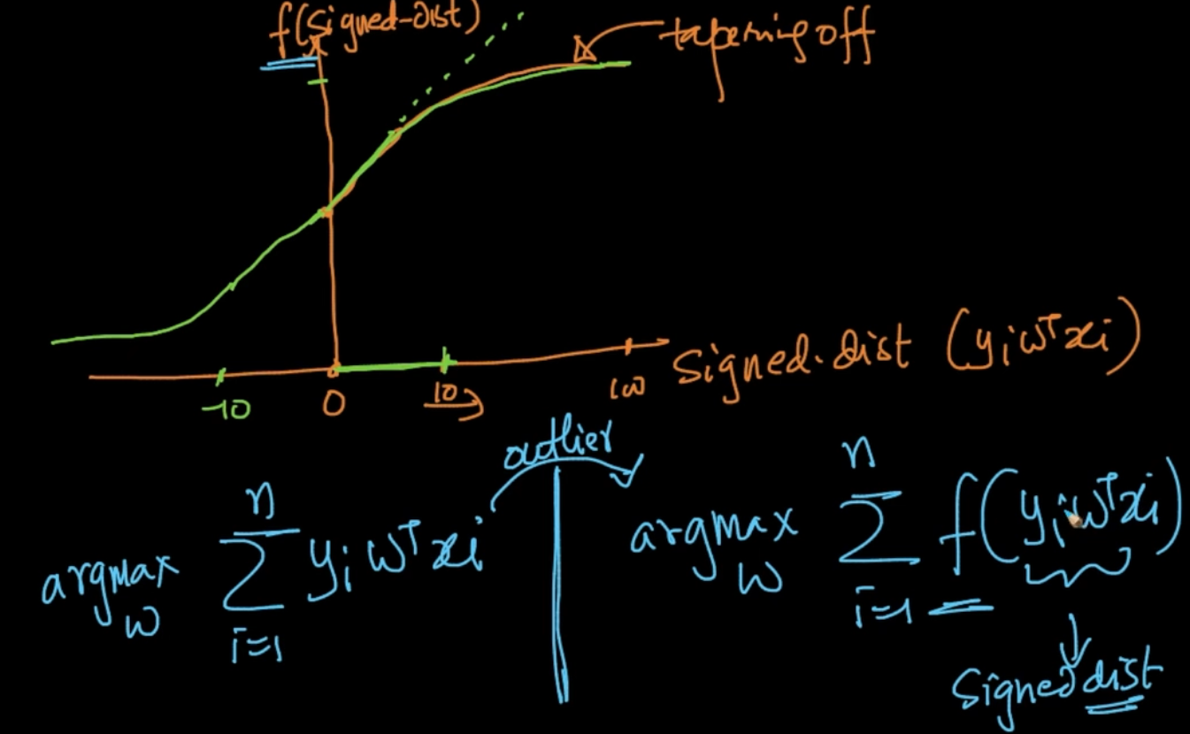

To get rid of the outlier we need a function such that after a certain distance ,10 here it’ll taper off. That’s max f($\sum_{i = 1}^{n}{}y_{i}w^{T}x_{i}$). In the above example our outlier with distance 100 is changing our whole model so it should be tapered down . So we need to find that function f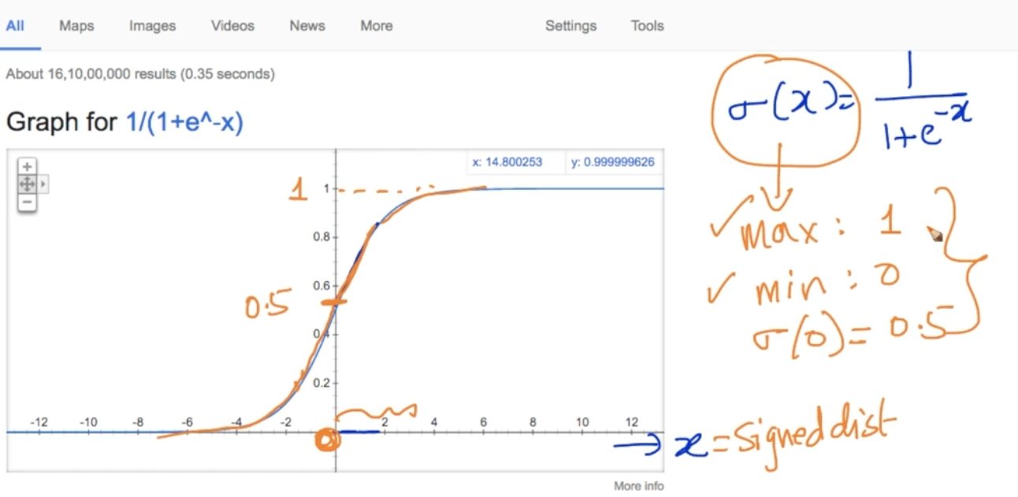

One such function is sigmoid function. We can see that till a certain value it’s increasing linearly but after that it’s getting tapered down and it’s maxed value is 1 so if our x: signed distance > 3 here it’s y will be 1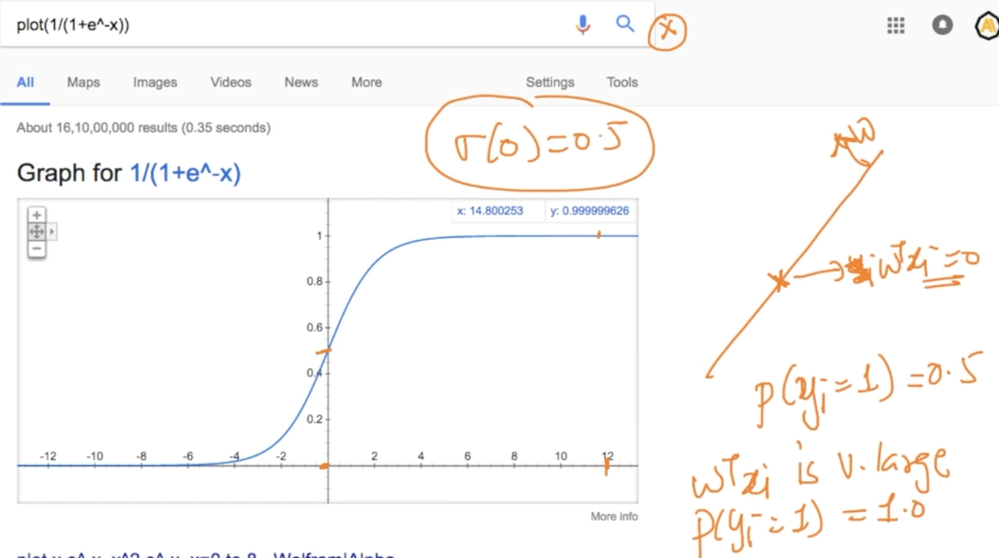

This sigmoid function has nice probabilistic interpretability properties . For ex: If the point is at plane then $w^{T}x_{i}$ = 0 therefore P($y_{i}=1$) = 0.5 because we don’t know whether it’s +ve or -ve . If the distance $w^{T}x_{i}$ is large say 12 here our P($y_{i}=1$) = 1.

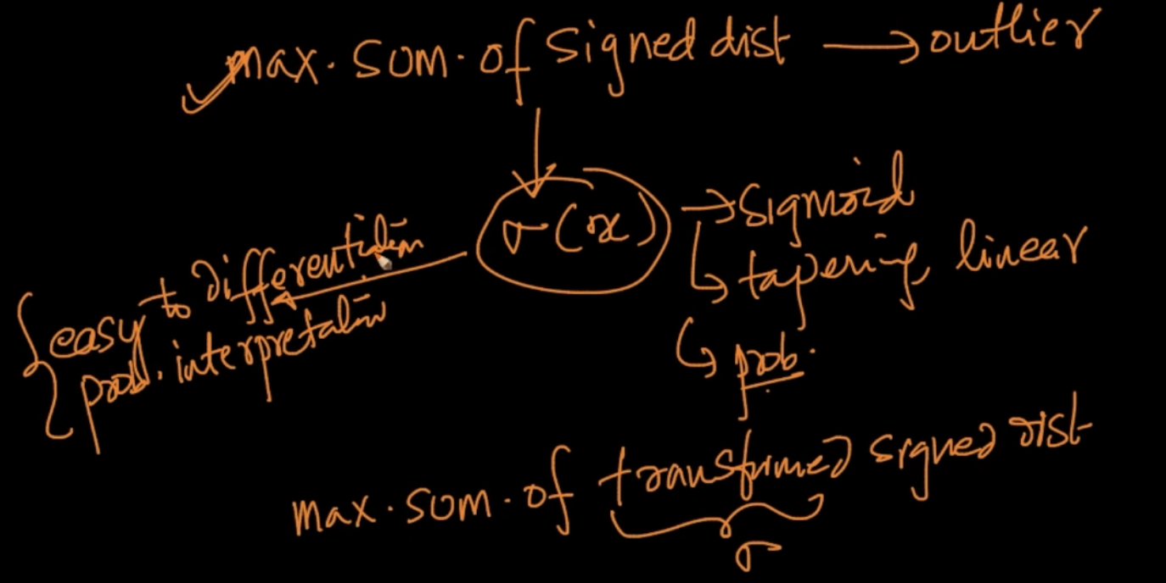

We wanted max sum of signed distance but it’d problem of outlier so we are using a function $σ$ (x) which has some nice properties mentioned above. So we want max sum of transformed signed distance with $σ$.

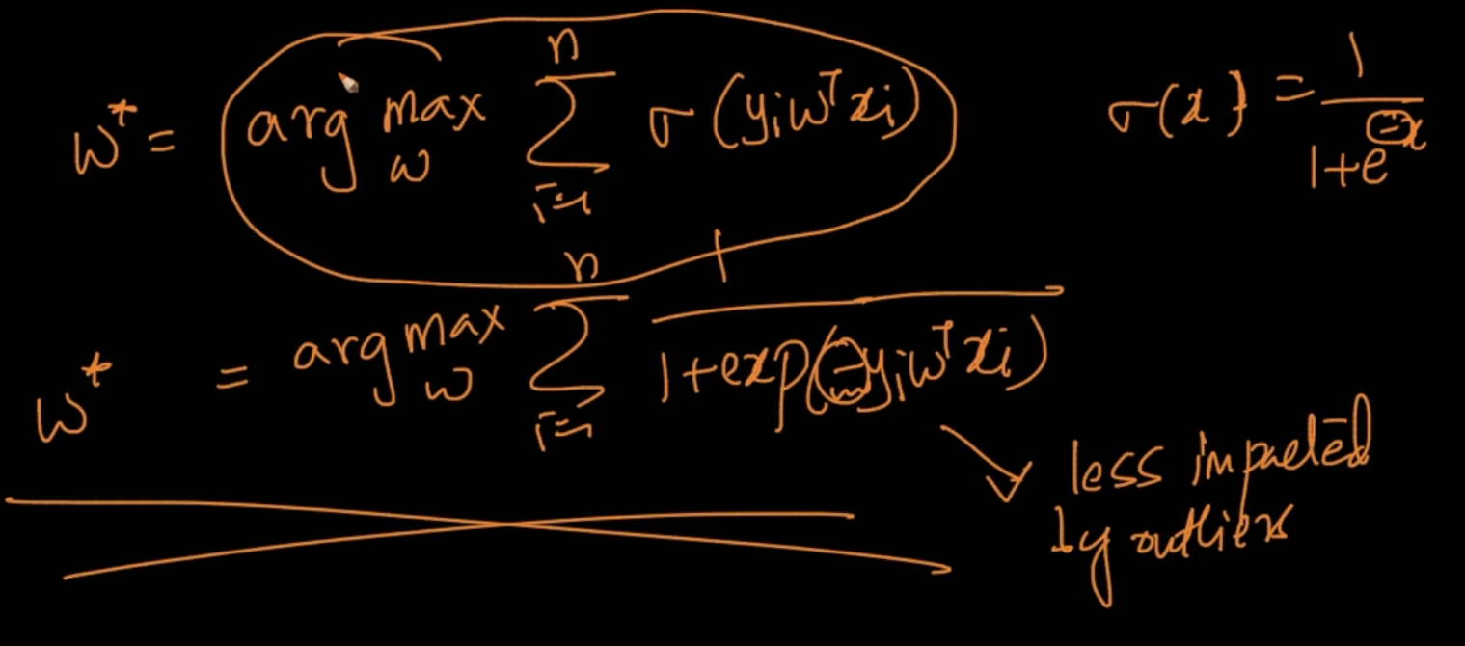

So our goal is to find optimal w : $w^{*}$ = argmax $\sum_{i=1}^{n}{}$ $\frac{1}{1+ exp(-y_{i}w^{T}x_{i})}$

# **MATHEMATICAL FORMULATION OF OBJECTIVE FUNCTION**

A monotonic function is a function which gets increased with x

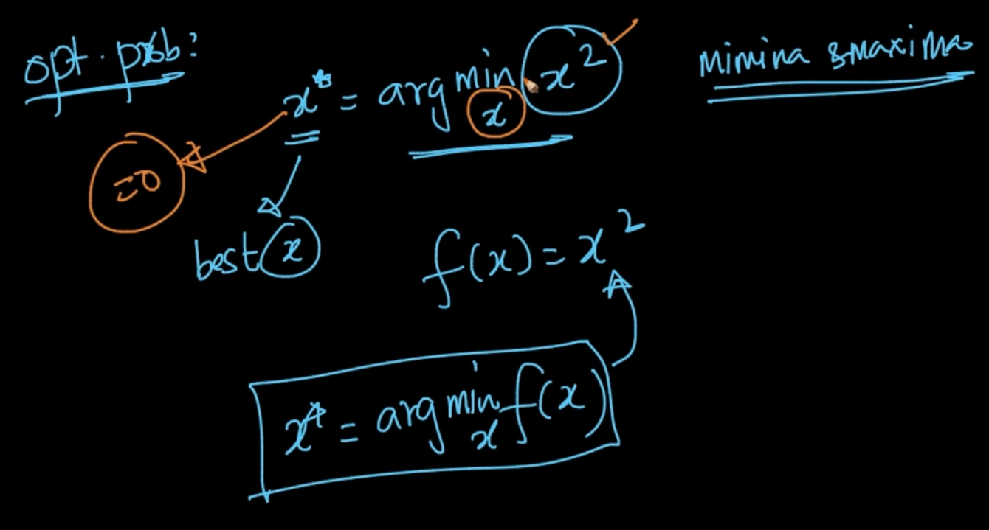

We are finding the minima of $x^{2}$ which is we can see from the plot is 0

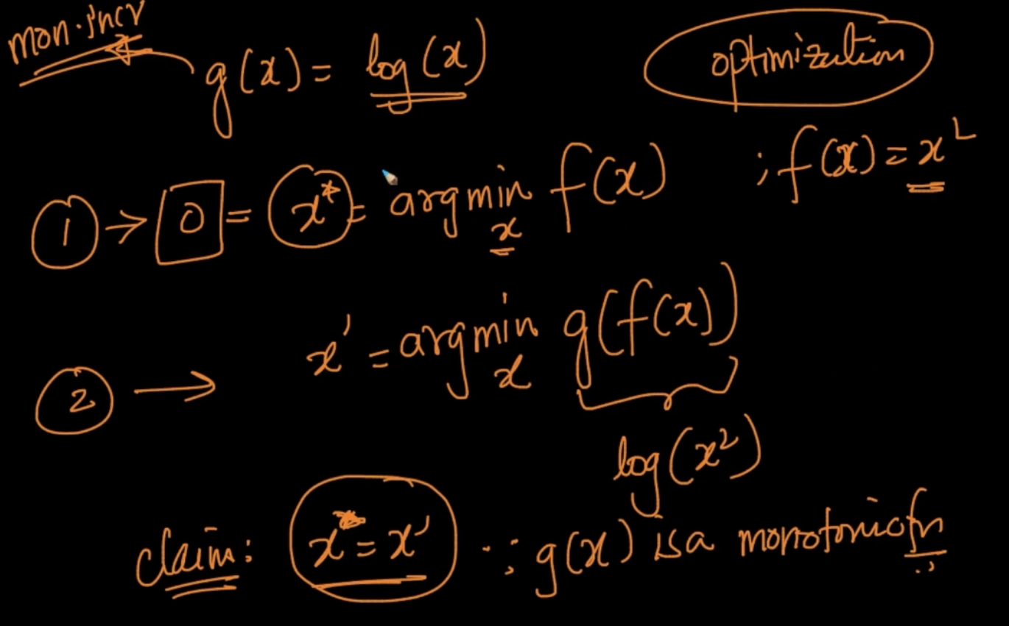

g(x) = log(x) which is a monotonically increasing function. We say here that $x^{*}$ = x’

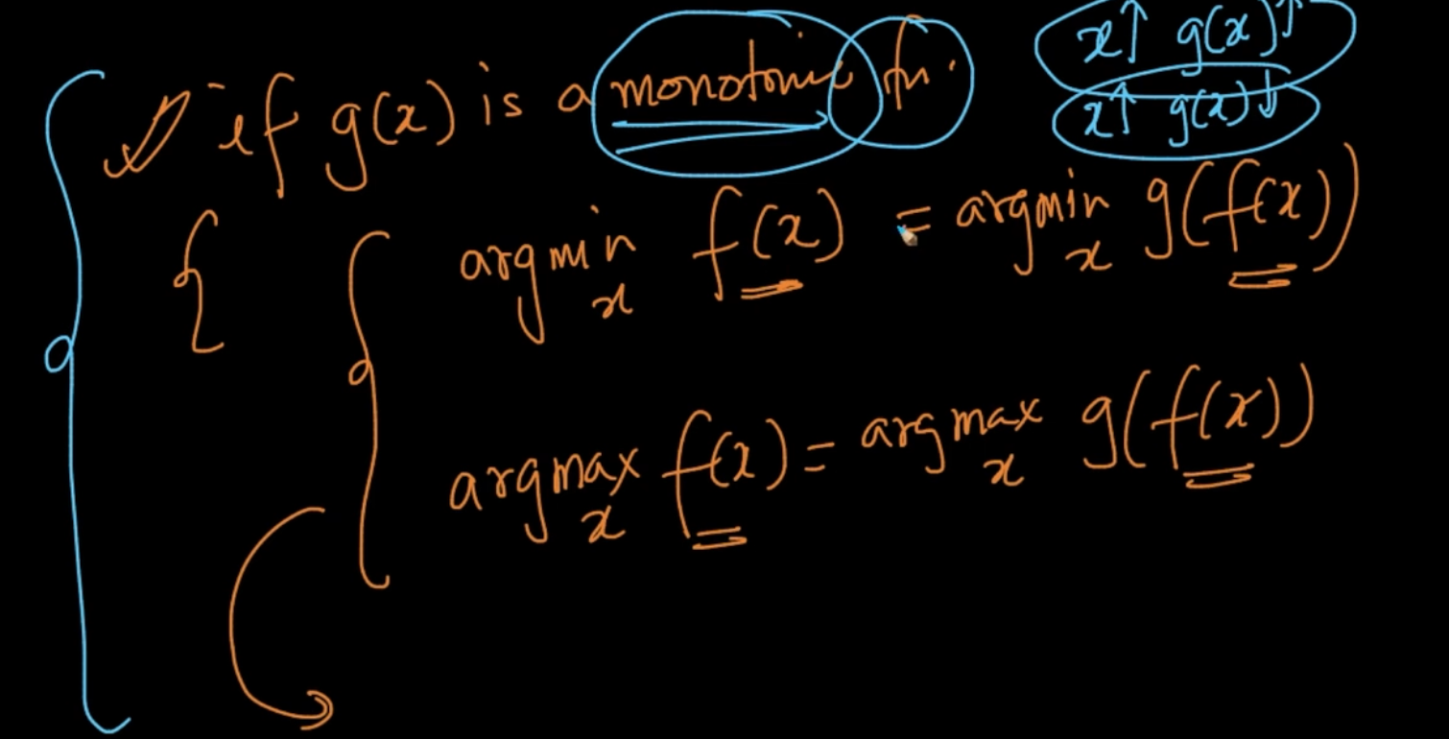

Here’s the condition here.

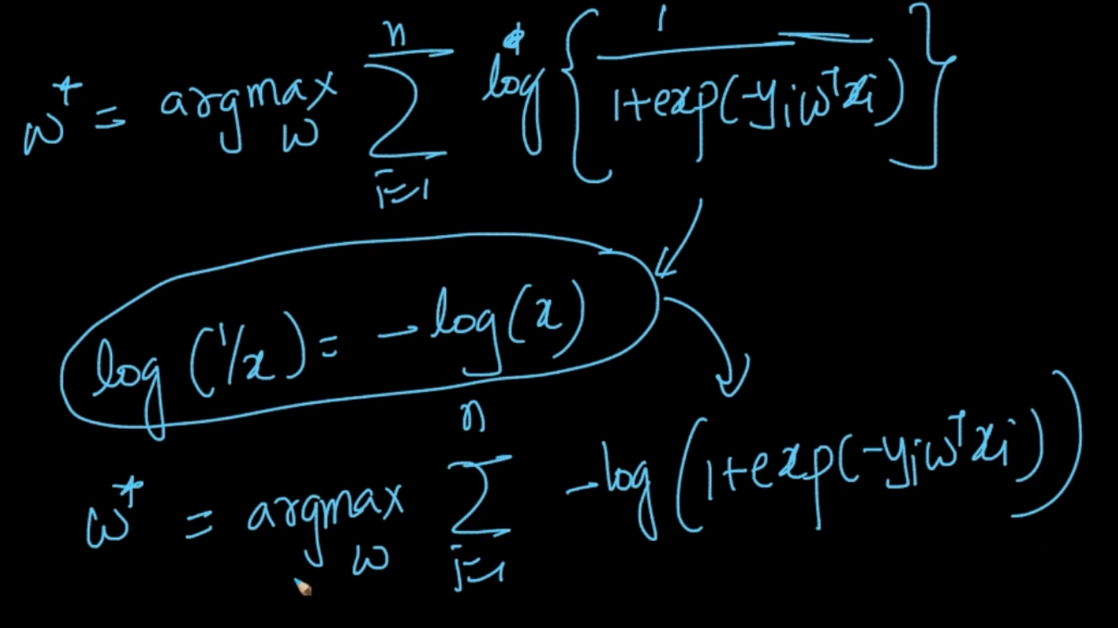

We have applied log to to the sigmoid function and getting that equation

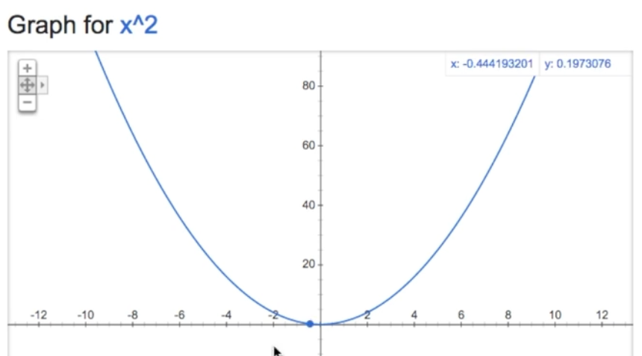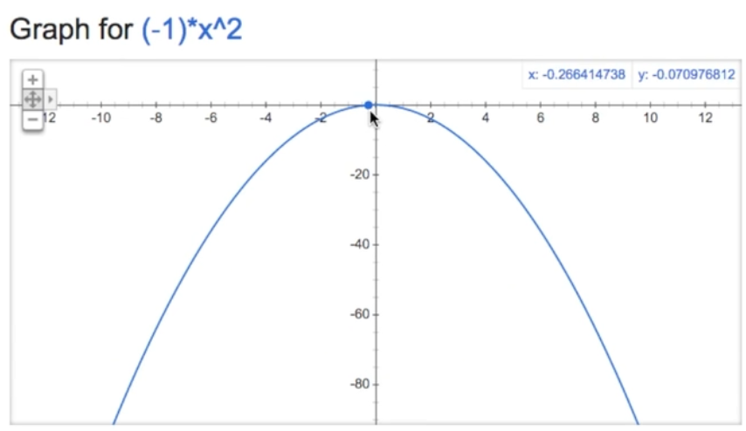

Minimum of $x^{2}$ = Maximum of ${-x}^{2}$. So we do the same to the above function as well

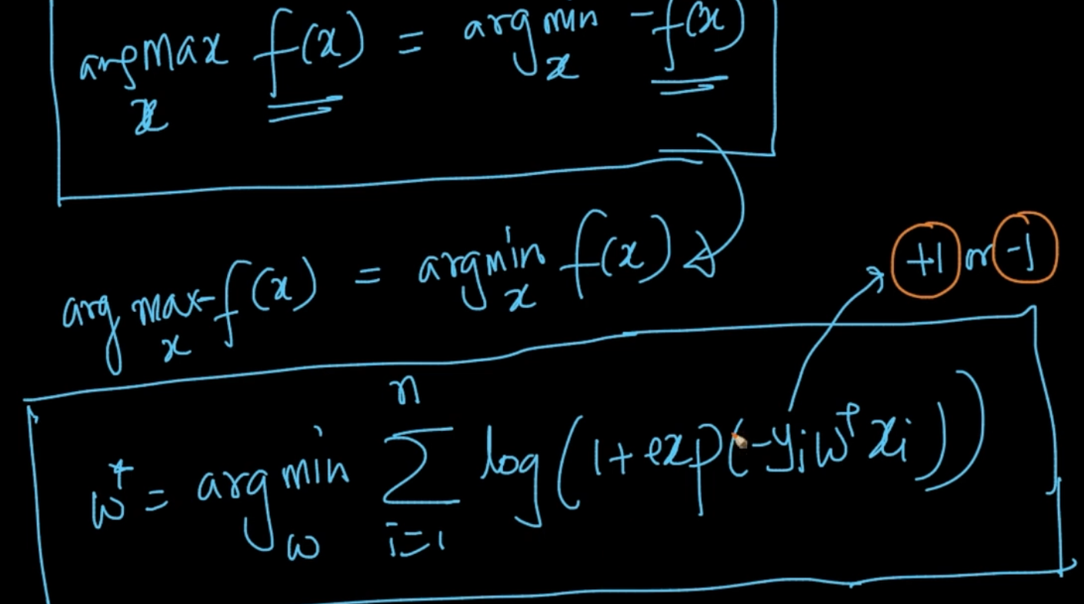

We want to find minimum(log(1 + exp(${-y}_{i}w^{T}x_{i}$)) )

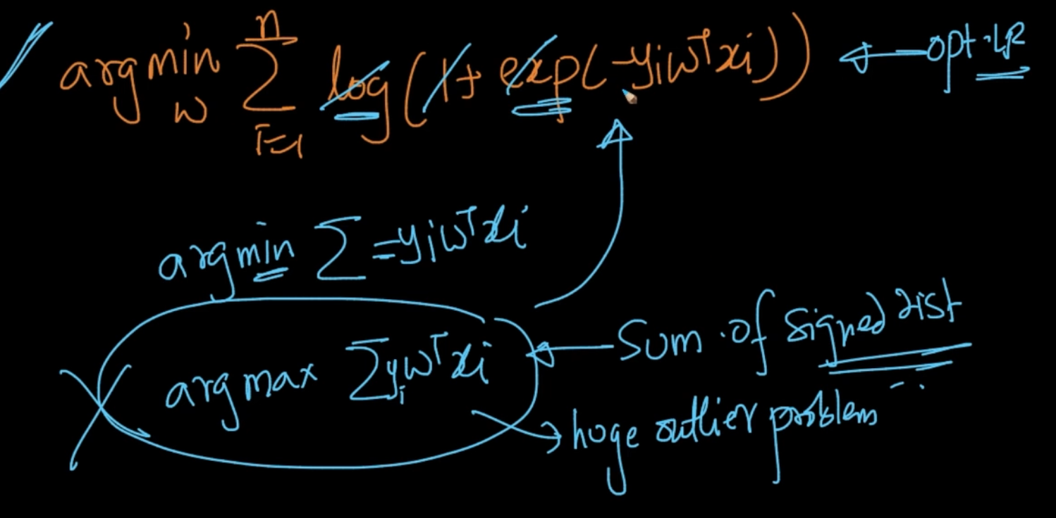

If we remove 1 from that we’ll only get $y_{i}w^{T}x_{i}$ which is sum of signed distance but we are not solving that problem since it gives us a huge outlier problem

# **WEIGHT VECTOR**

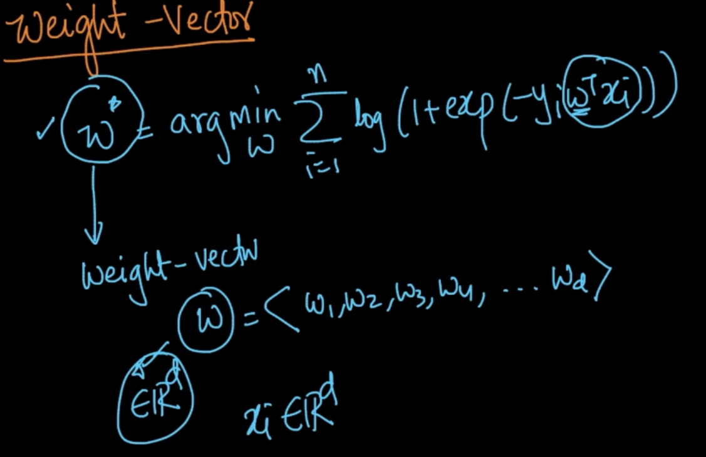

We want to get the optimal w which is also known as weight vector which has d-dimensions as well as x has d- dimensions

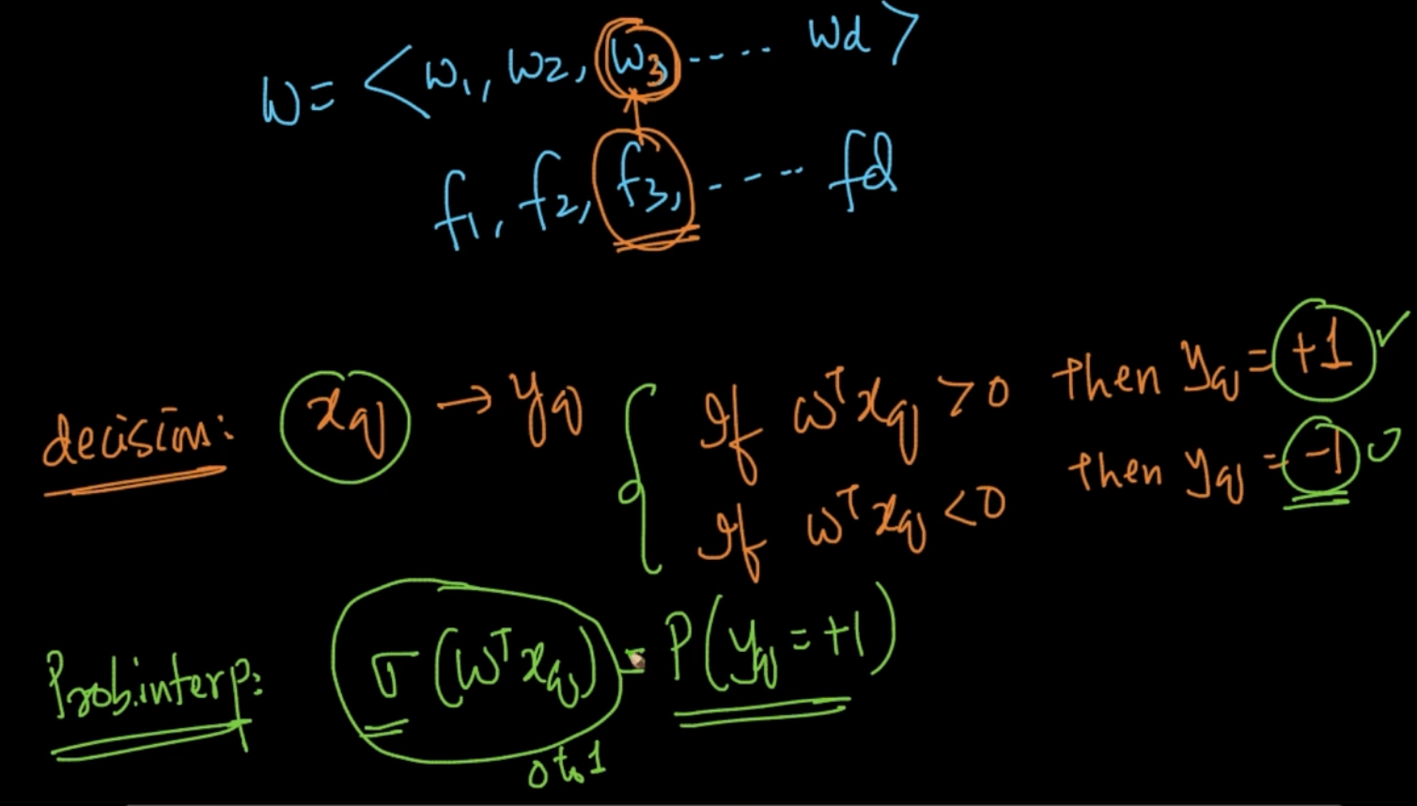

This is how we predict the class label y. We can also get probabilistic interpretation using sigmoid function

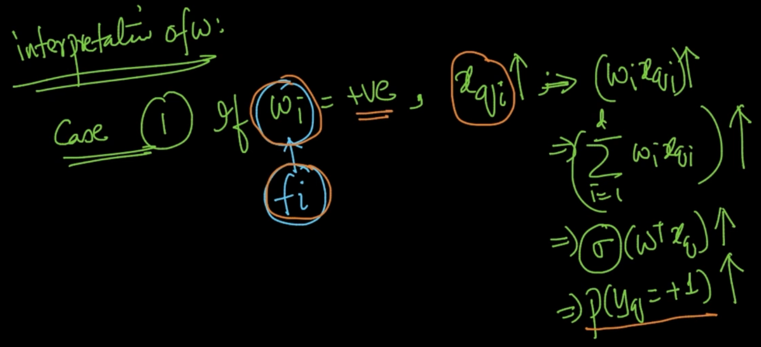

**Case 1:** If $w_{i}$ corresponding to a feature $f_{i}$ = +ve and $x_{qi}$ $↑$ then all the other things get increased as well. As $x_{qi}$ $↑$ => P($y_{q}$ = +1) $↑$ 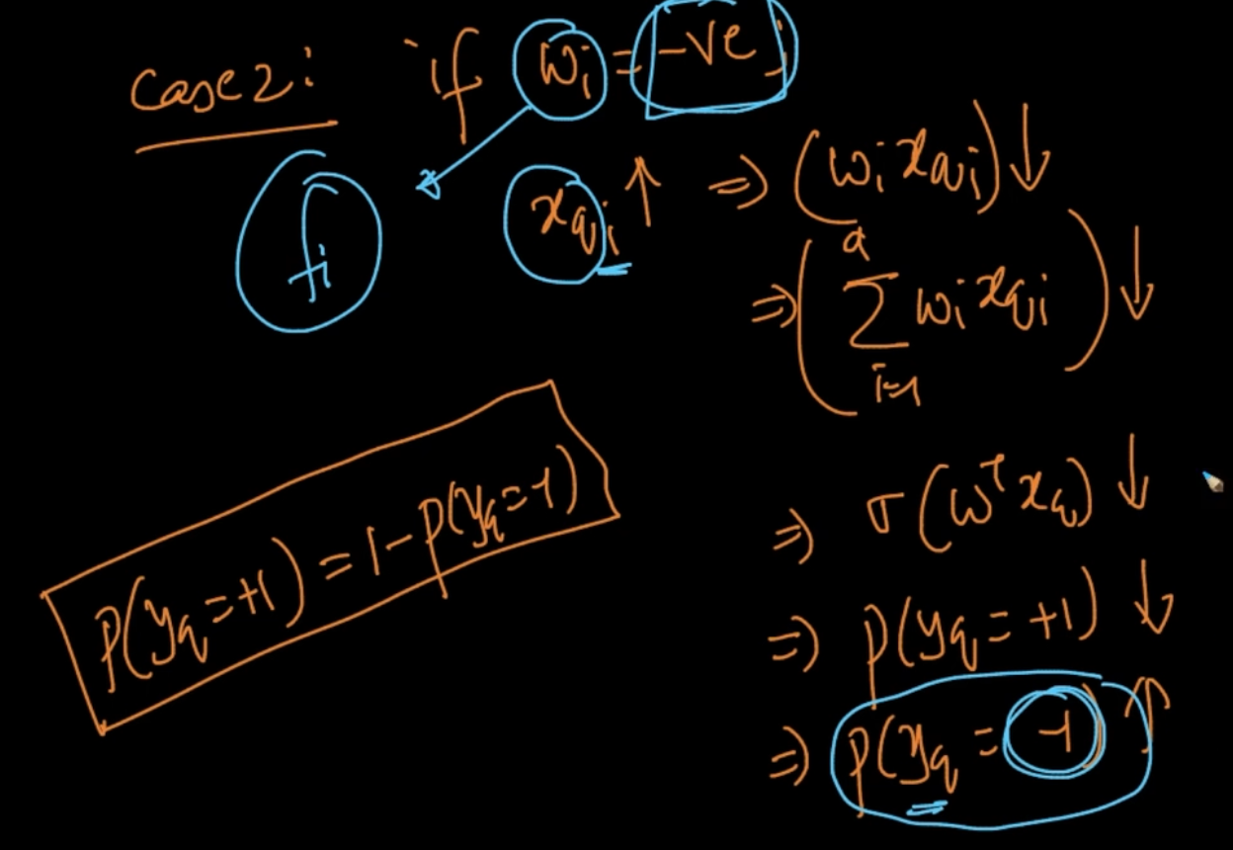

**Case 2:** If $w_{i}$ = -ve and $x_{qi}$ $↑$ then all the other things will get decreased and P($y_{q}$ = +1) $↓$

but P($y_{q}$ = -1) $↑$

# **L2 REGULARIZATION OVERFITTING AND UNDERFITTING**

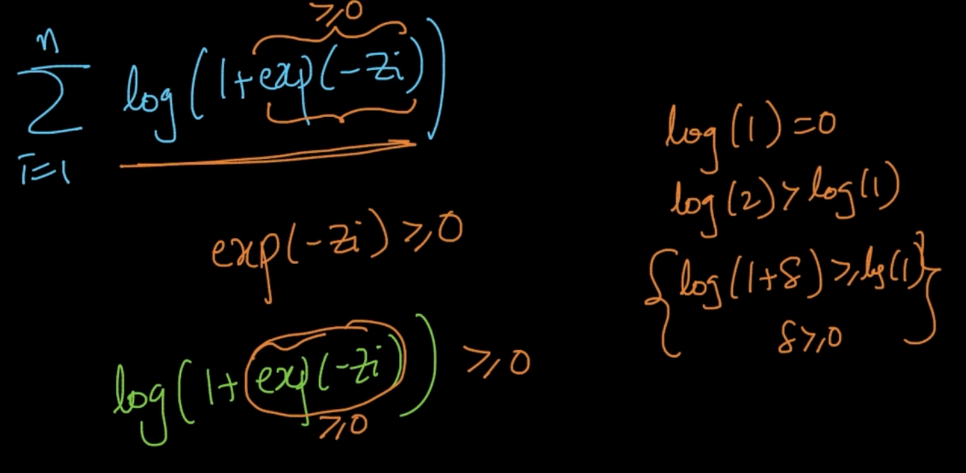

exp(-z) $≫$ 0 and the value of our whole function > 0 since log(1 + $δ$) $≫$ log(1) and

$δ$ = exp(-z)

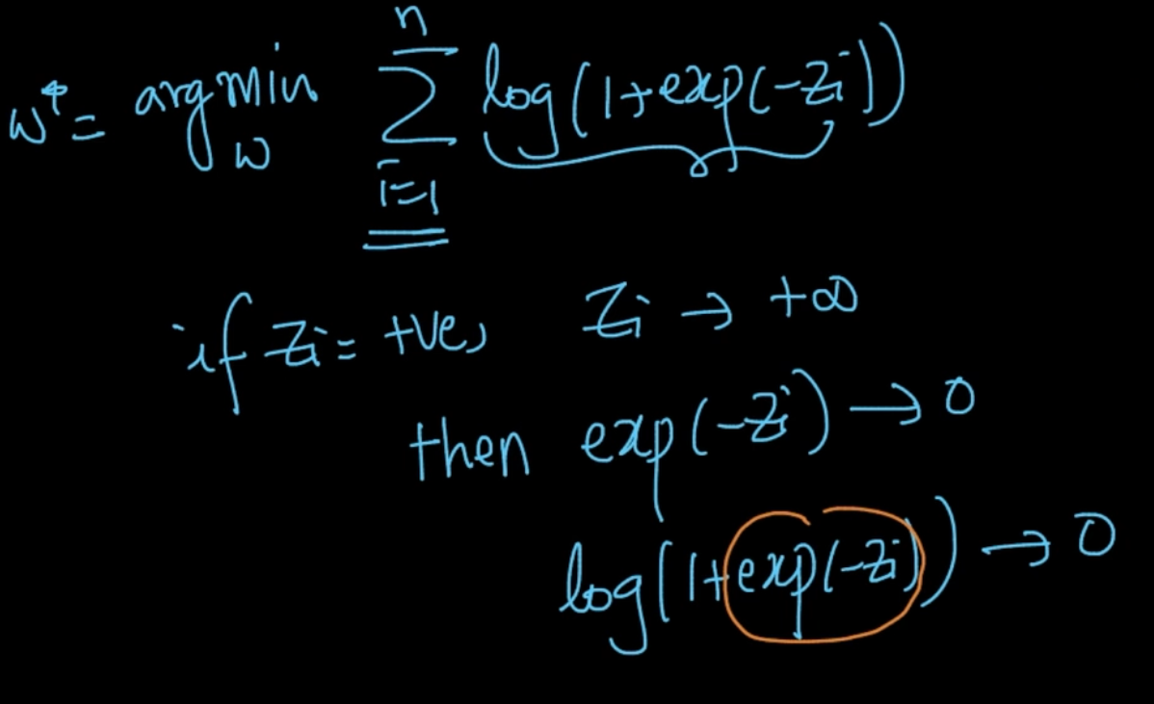

We want our z to be +ve for correct classification and if z -> $∞$ then exp(-z) -> 0

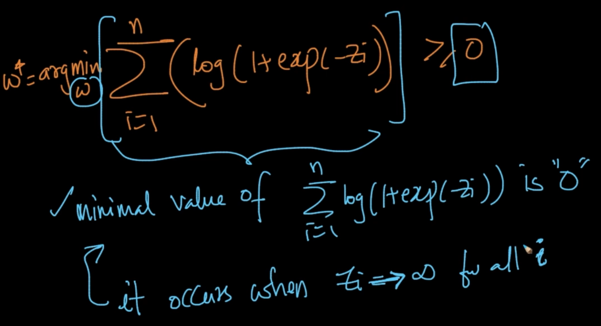

We want to minimize it and it’s minimal value is 0 when $z_{i}$-> $∞$ for all i

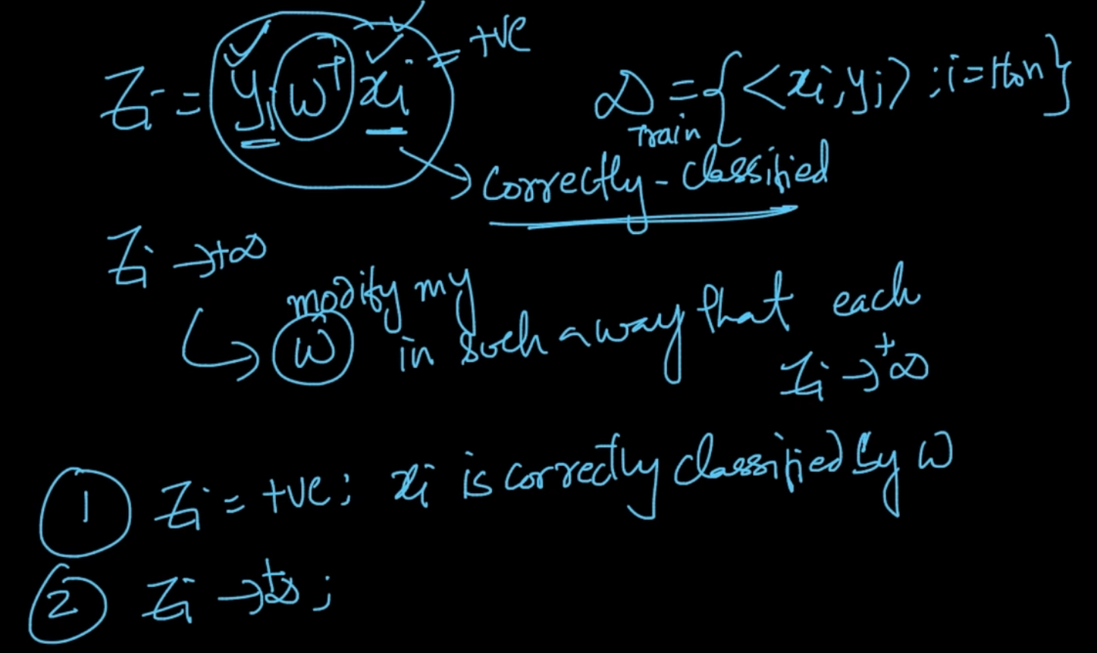

For $z_{i}$-> $+∞$ we need to modify w such that $z_{i}$-> $+∞$. SInce x and y are fixed w is the obly variable here

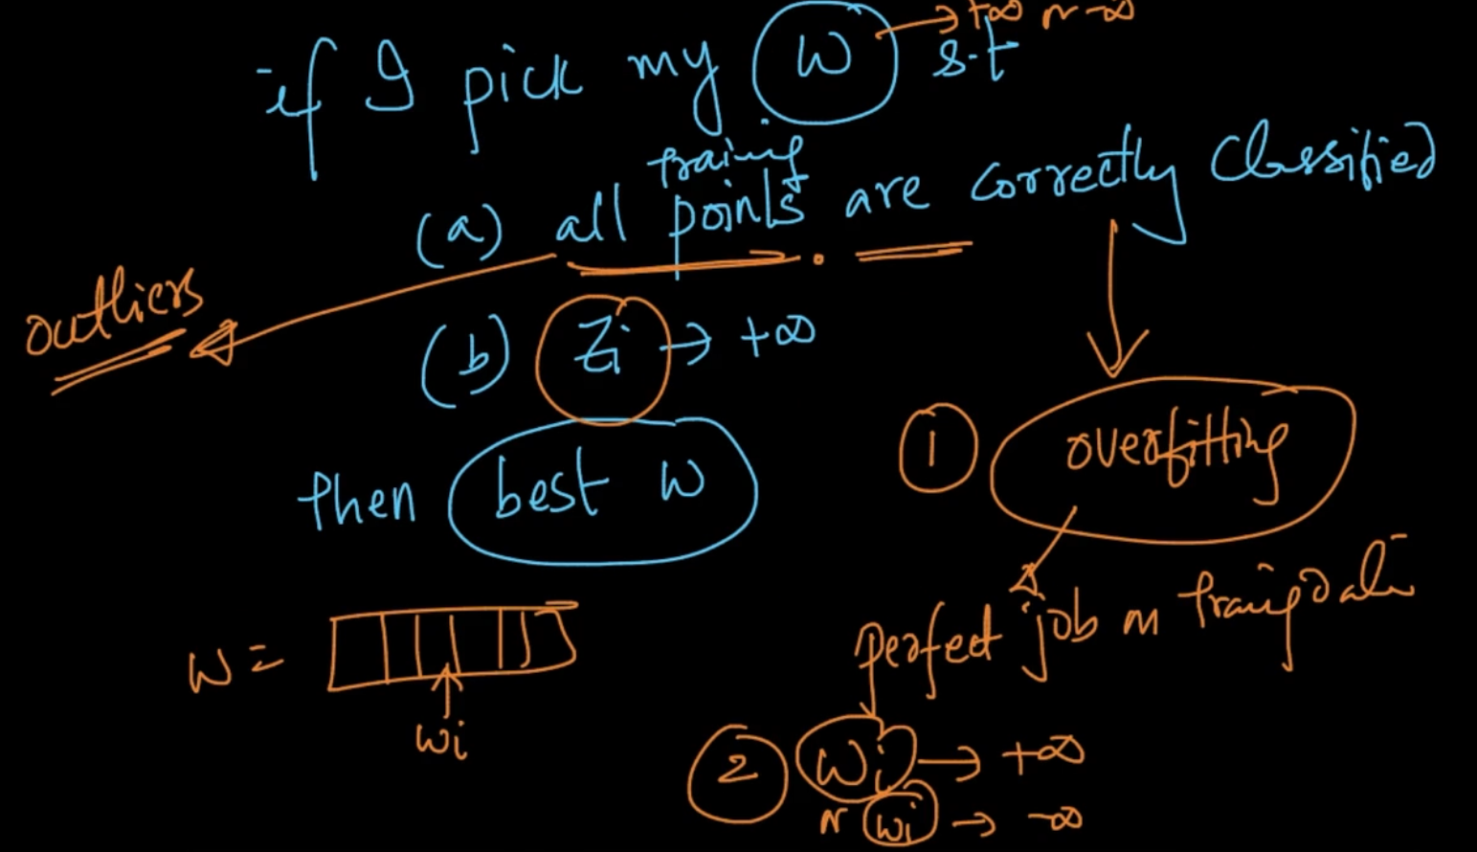

Since, our whole function is becoming 0 we are perfectly fitting the data . It means that it can be overfitting and since z -> + $∞$, $w_{i}$-> + $∞$ so it’s becoming too large

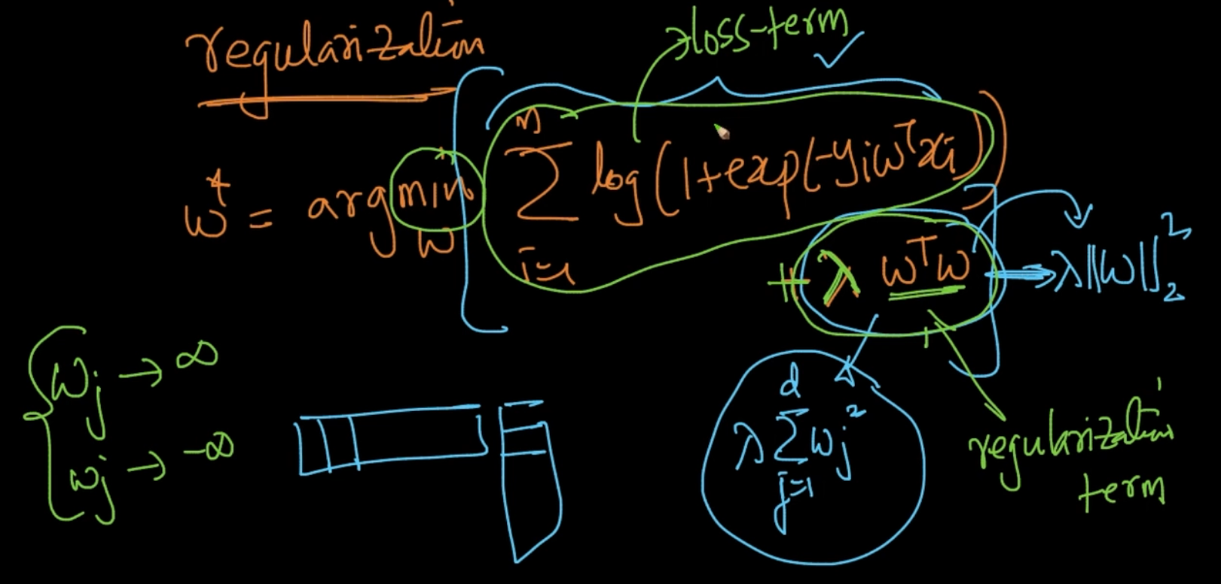

So we are adding $λ w^{T}w$ to our optimal w, known as regularization term. As w -> $∞$

Then our regularization term will also be $∞$ but we need to minimize it.

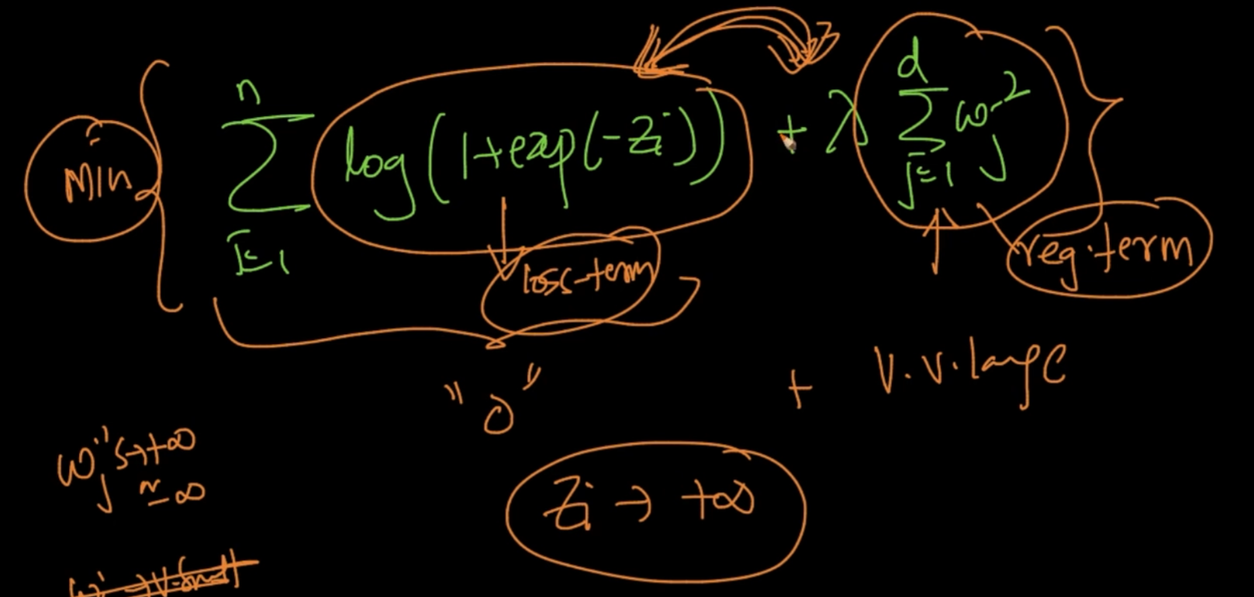

As $w_{j}$-> $∞$ our log function will be 0 as exp(- $z_{i}$) but our regularization term will be very large and since we want to minimize the whole it won’t happen as log function -> 0 means we are overfitting our data which we don’t want. So both loss term and regular term are fighting with each other to minimize the whole

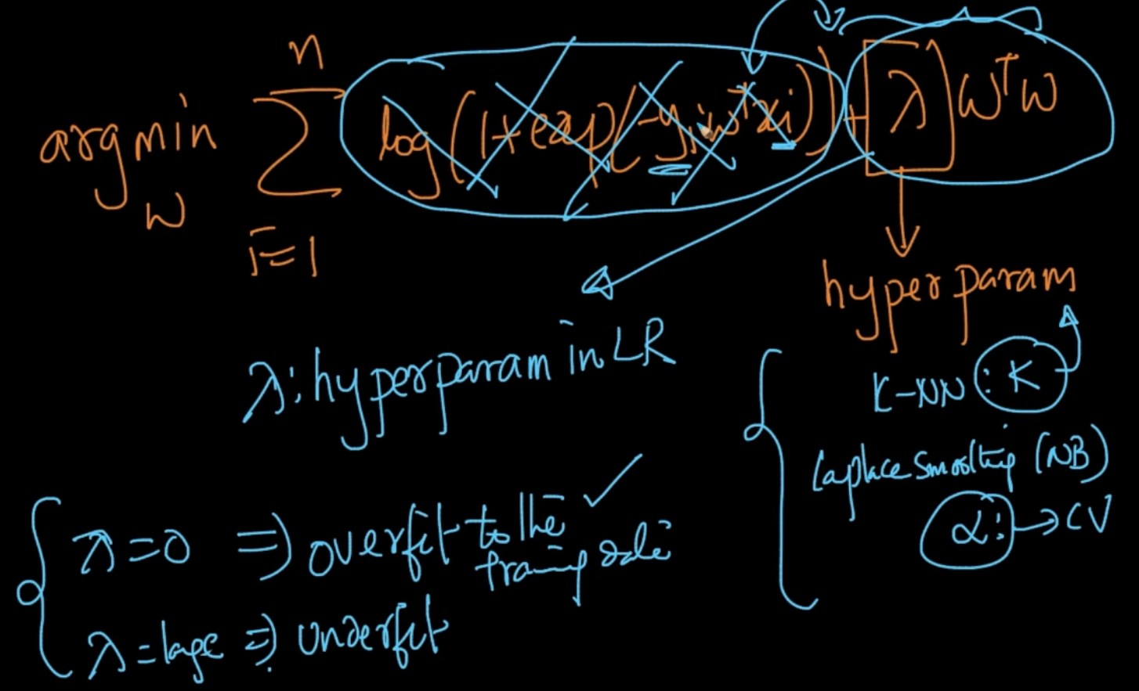

$λ$ is hyper-parameter as $λ$ = 0 => It’ll mean overfit to Training data and if $λ$ = large => Underfit since we are not using the training data i.e log thing and only w

# **L1 REGULARIZATION AND SPARSITY**

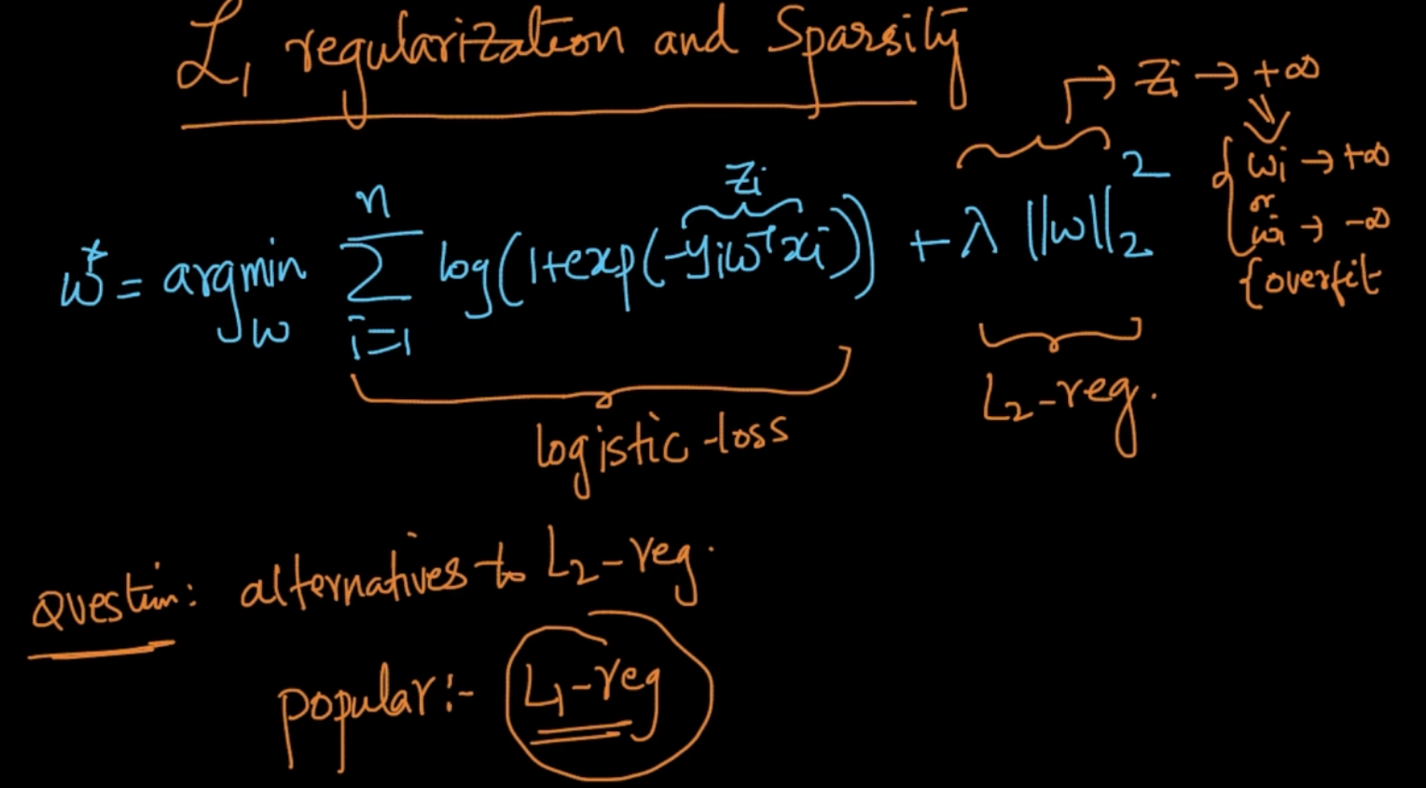

We’d seen L2 regularization now we see the other alternatives

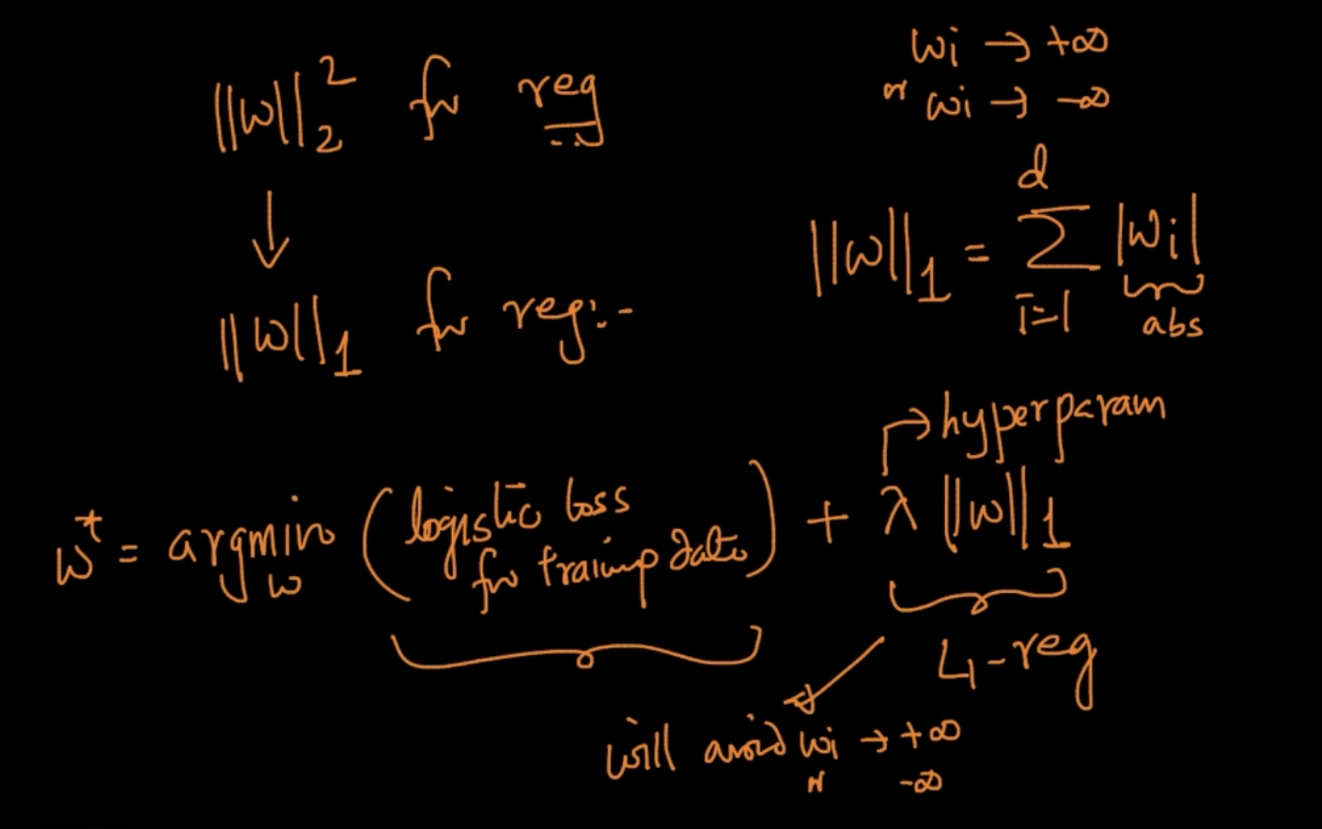

This is L1-Regularizer. It has absolute value of w. It’s different advantage as compared to

L2 which we’ll see below

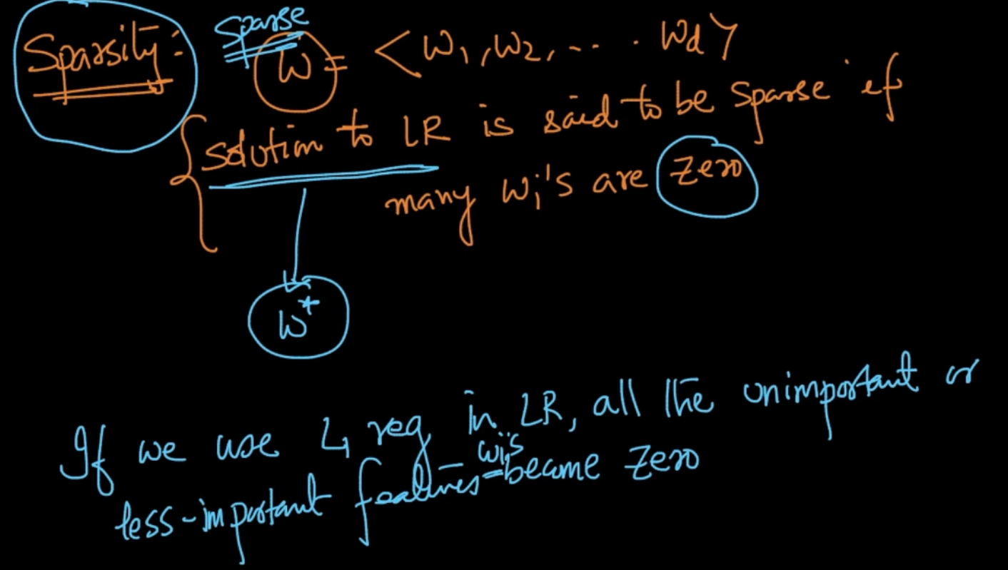

If we use L1 regularization then all the less important features become zero

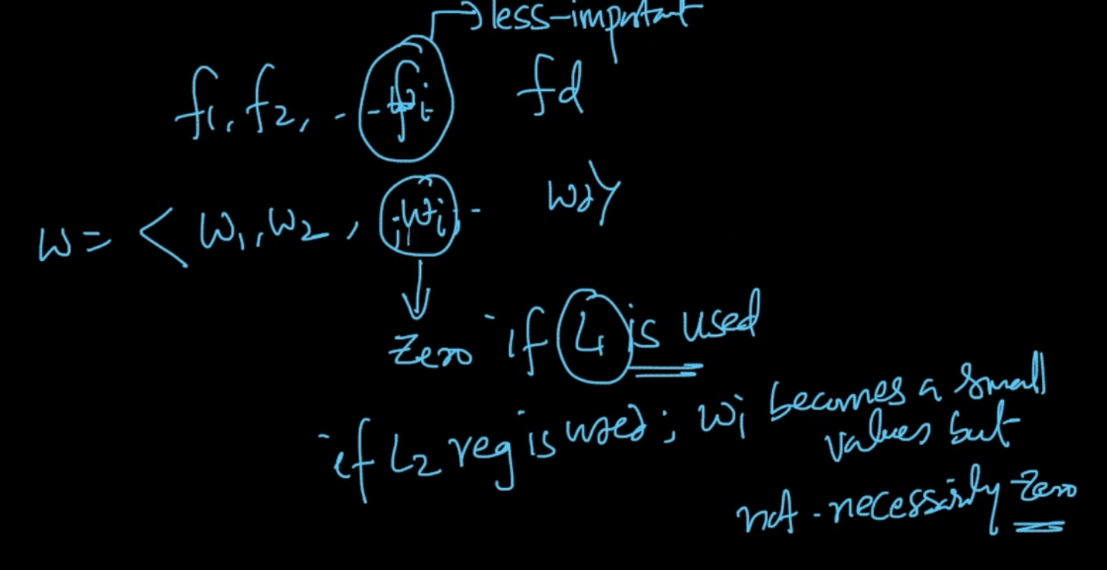

If we are using L1 regularization and feature $f_{1}$ is less important then it’s corresponding

$w_{i}$ will be zero as compared to L2 where $w_{i}$ becomes a small value

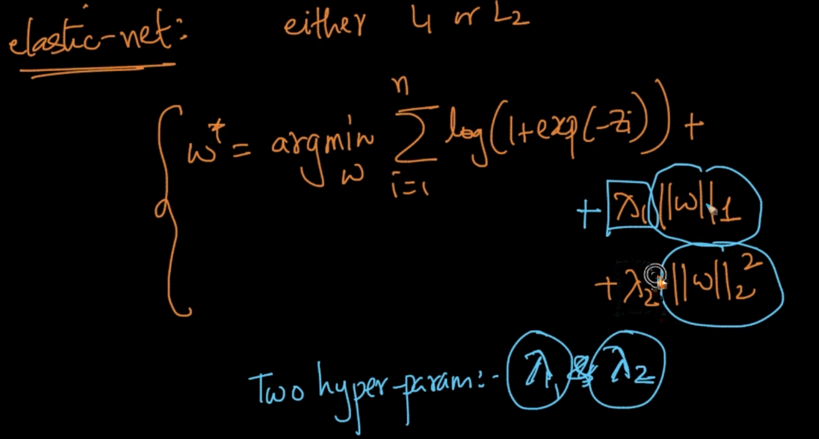

Elastic-Net is a combination of L1 and L2 regularization. It has two Hyper-parameters

$λ_{1}$ and $λ{}_{2}$ which can be found out through cross-validation

# **PROBABILISTIC DERIVATION OF LOGISTIC REGRESSION**

If these two points are true the Logistic Regression can be derived using probability

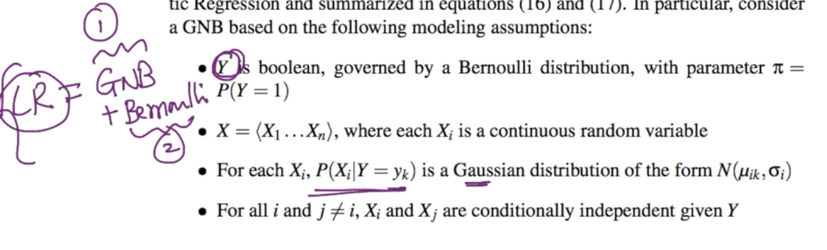

If the above assumptions are true we can easily derive i.e P(y = 1| X) = $\frac{1}{1+ exp(\sum_{i=1}^{n}{}w_{i}X_{i})}$

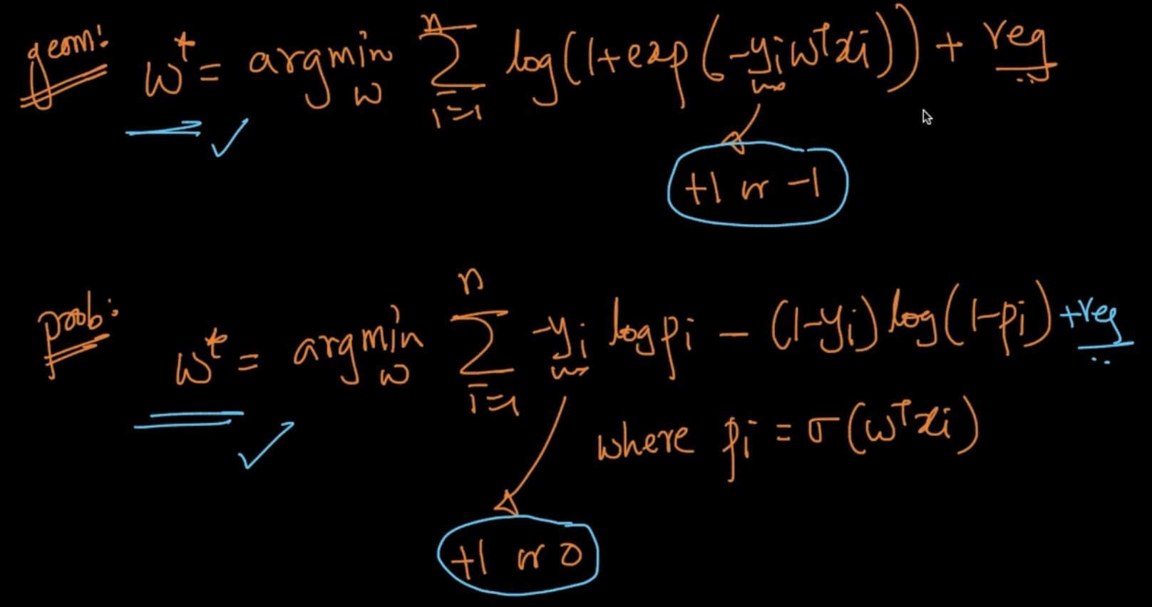

Both the formulae are same but in Geometric , y has +1 or -1 value and Probabilistic

y is +1 or 0

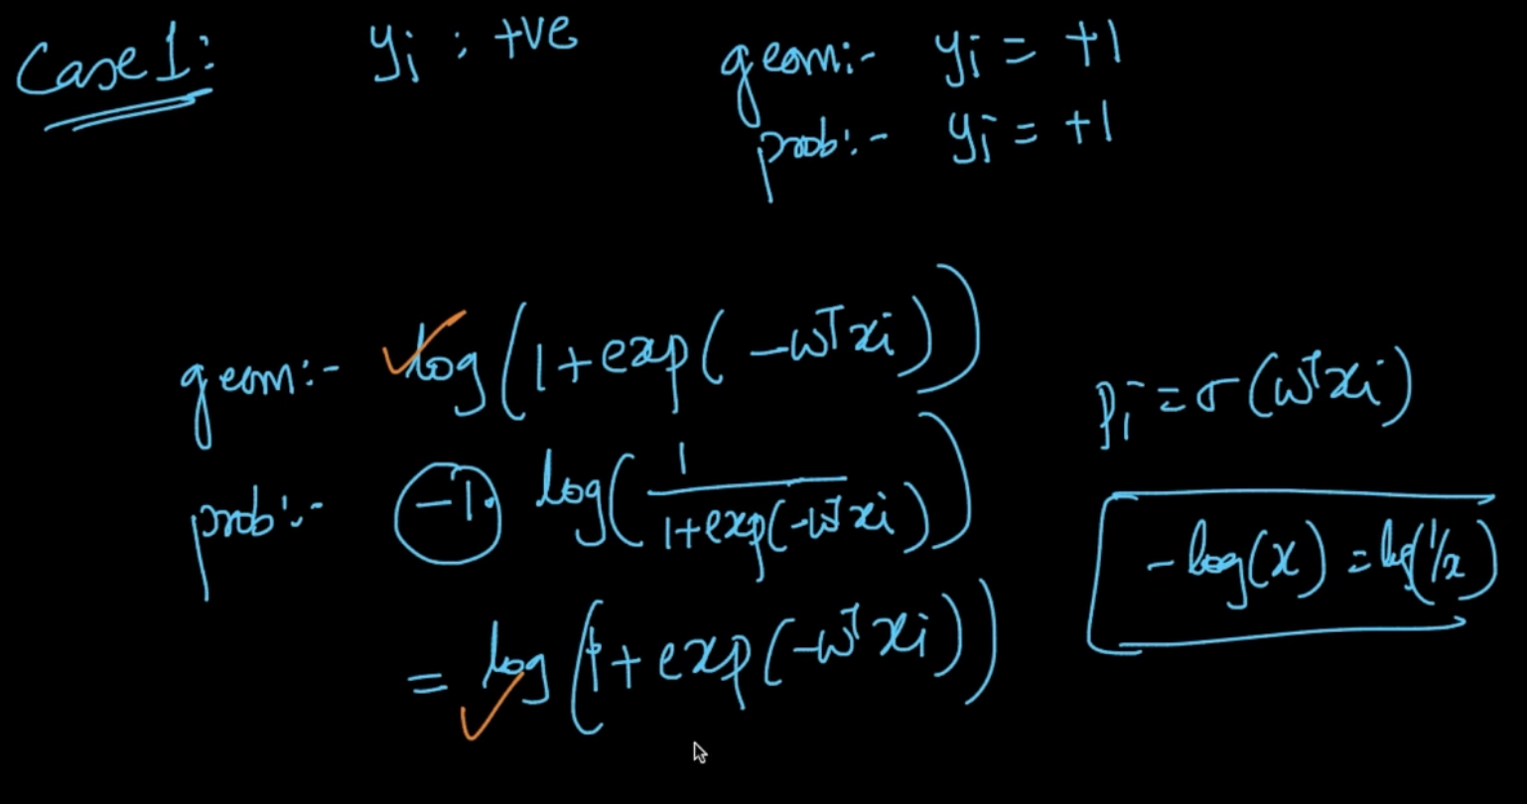

**Case 1:** Here, y = +1 and if we do the math both will be same

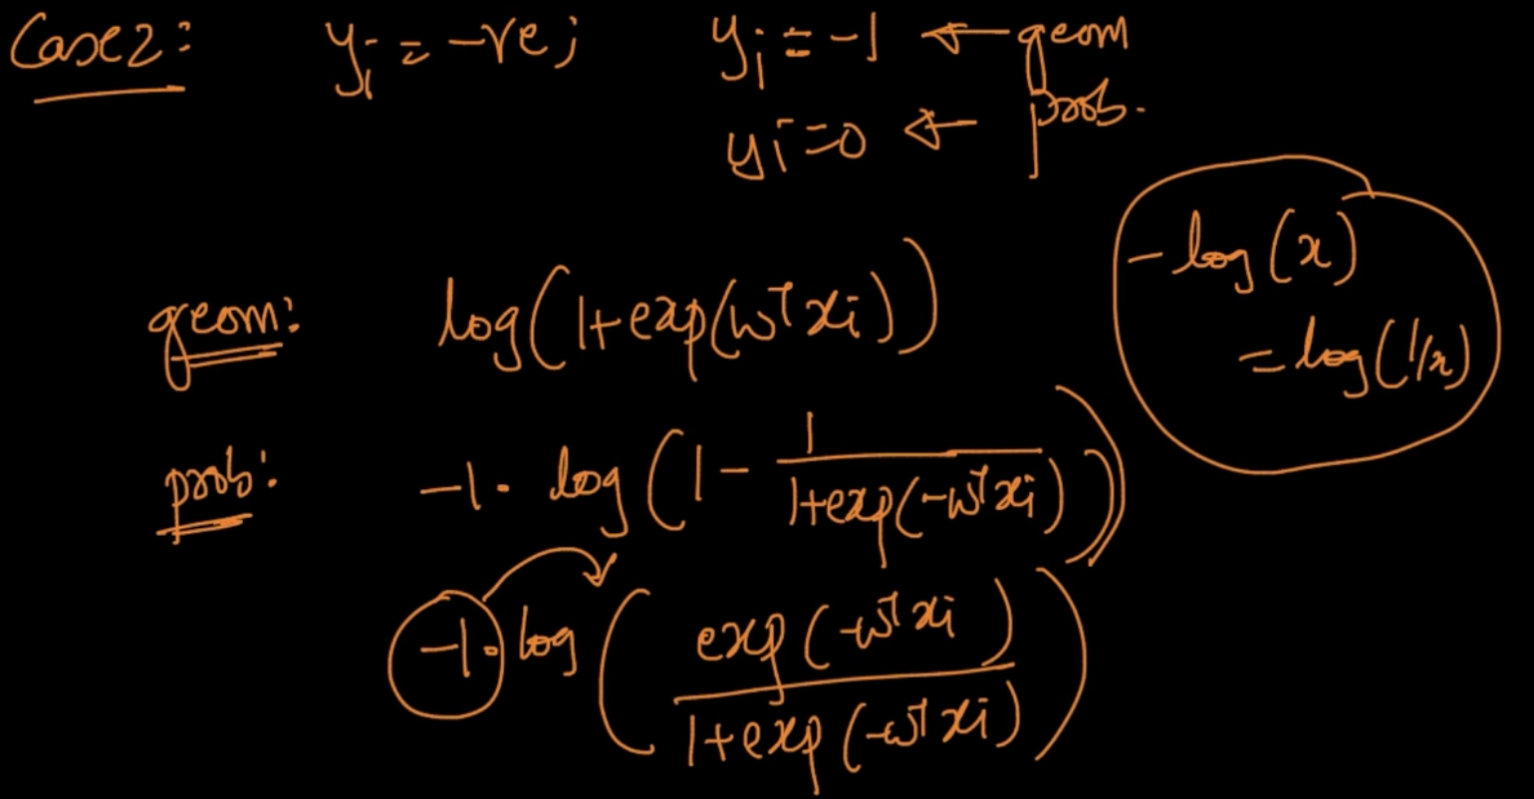

**Case 2**: Here, y = -1 in Geometry and y = 0 in probability. We are inverting the numerator and denominator using property -log(x) = log(1/x)

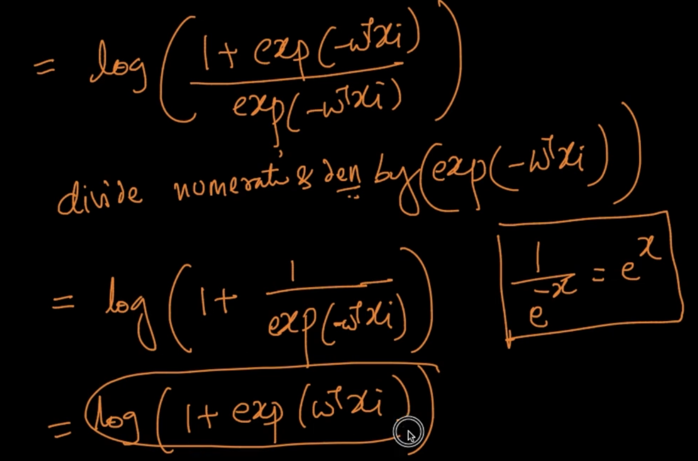

As we can see the Probabilistic measure is deriving to the same thing

# **LOSS MINIMIZATION INTERPRETATION**

We’d seen Geometric and Probabilistic interpretation now we’ll see loss minimization

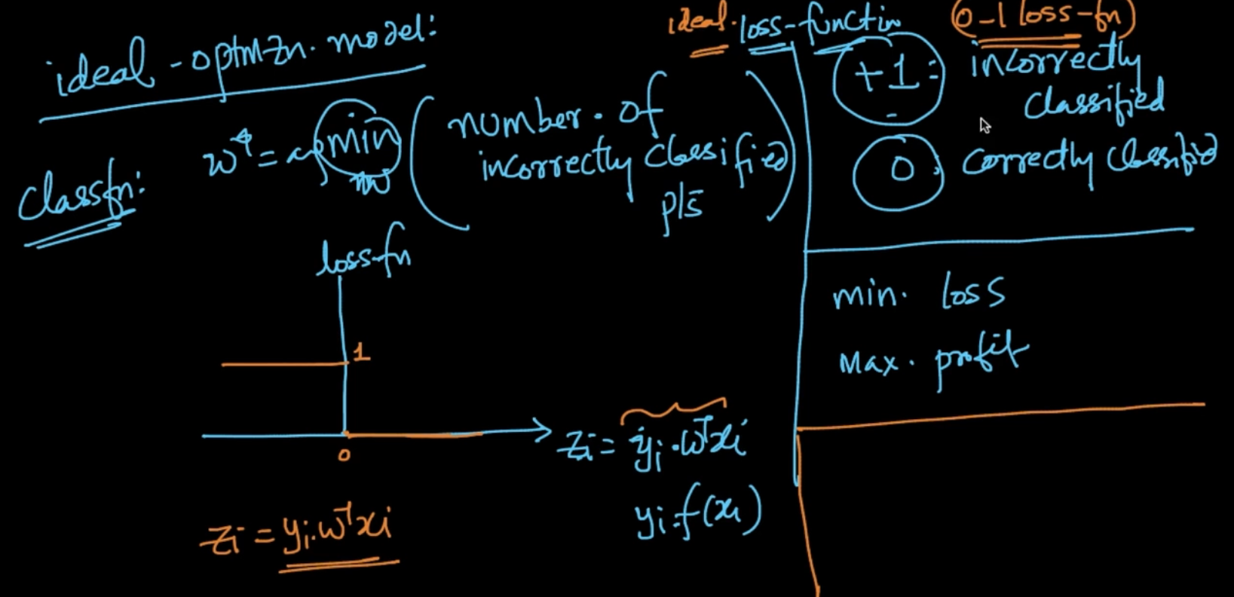

In our ideal optimization model we want to minimize the number of incorrectly classified points. Our loss function is saying that if +1: Then incorrect classification and 0 if correctly classified. So in the graph if z < 0 => 1 and if z > 0 then 0

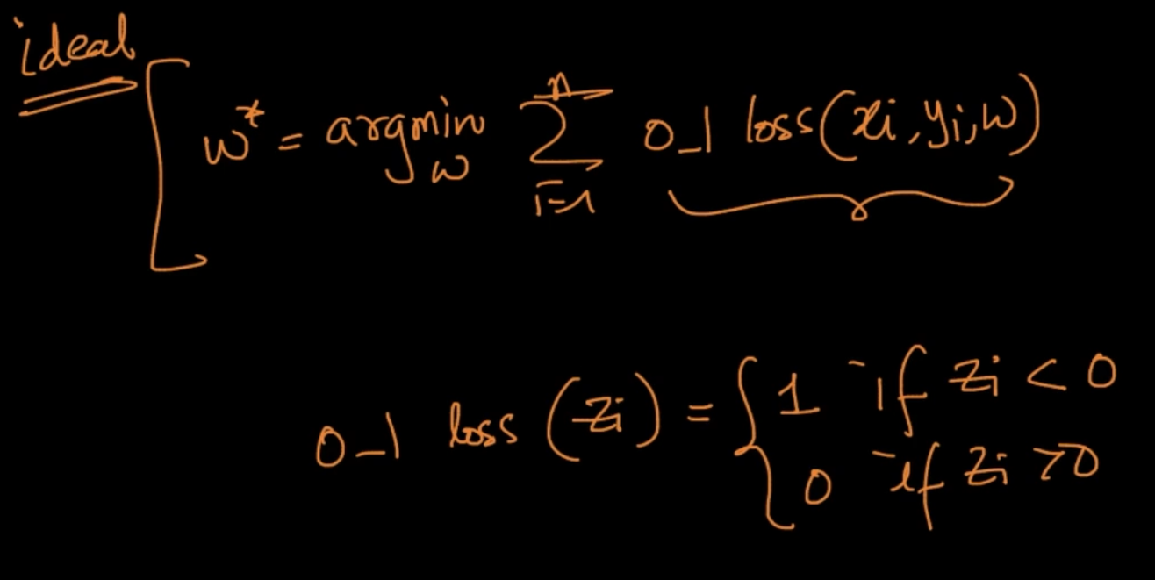

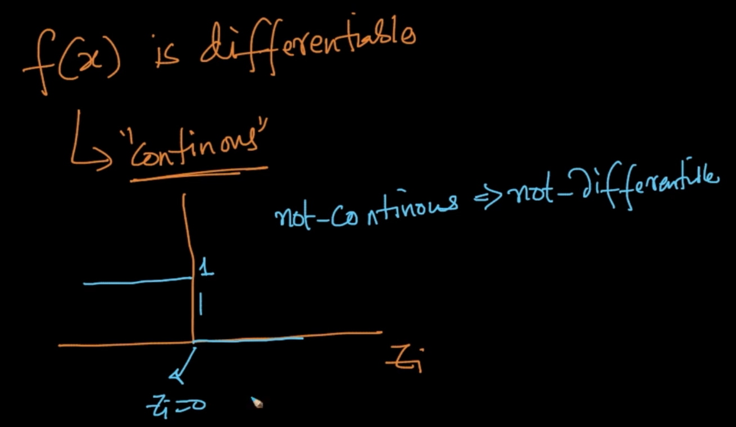

But to solve the optimal model we need to differentiate the function f(x) and for function f(x) to be differentiable f(x) should be continuous

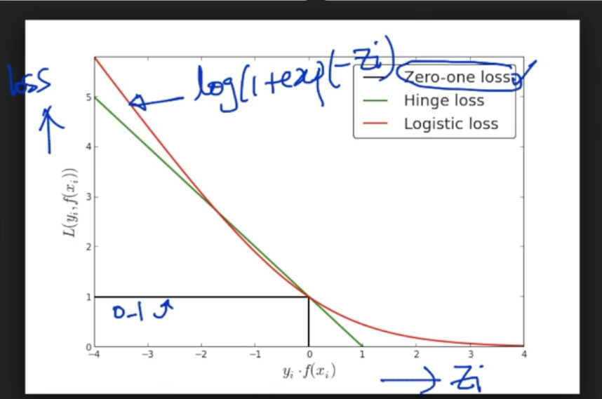

0-1 is not continuous hence not differentiable. So we’ll approximate it by using continuous functions. We are using log-loss where y = log(1 + exp(-z)) where z = y.f(x) and f(x) = $w^{T}x$

We could’ve drawn any other loss function as well but for logistic regression Logistic loss is used. Here, if z > 0 it’s getting close to 0 after certain value but when z < 0 it’s increasing sharply

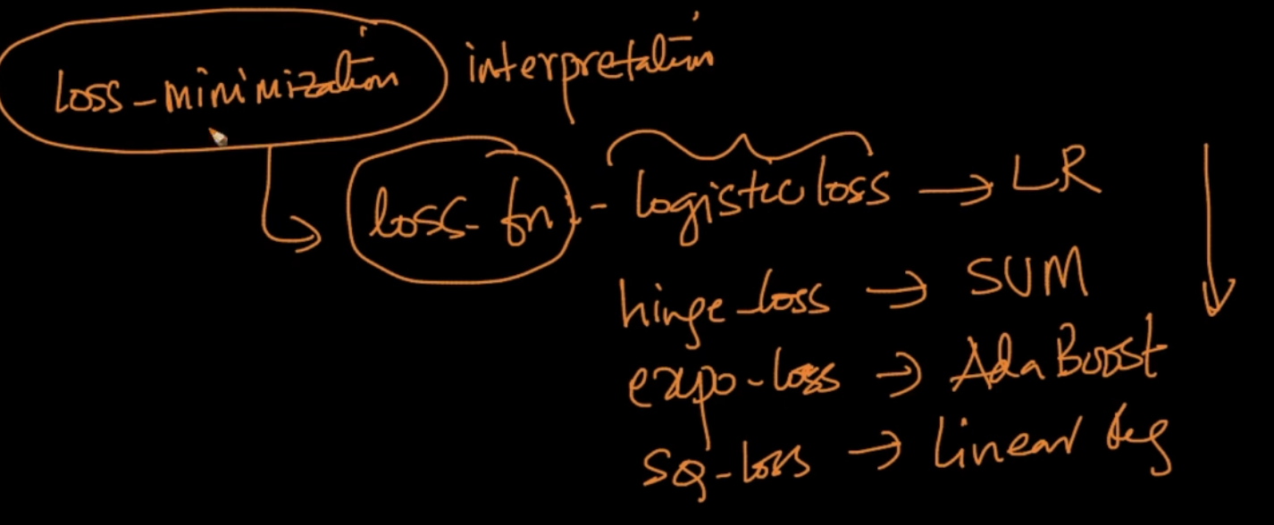

Different loss function for different ML algorithms

# **HYPERPARAMETER SEARCH/OPTIMIZATION**

We want to identify the best $λ$ for Logistic Regression. In k-NN, we found the best k by plotting the CV-error vs k graph and checking whichever k gives lowest CV error is our k

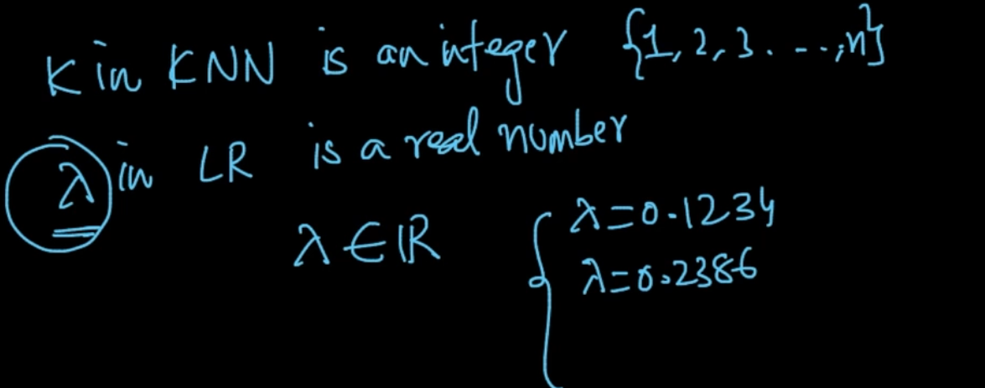

But our k in k-NN is an integer but our $λ$ in LR is a real number

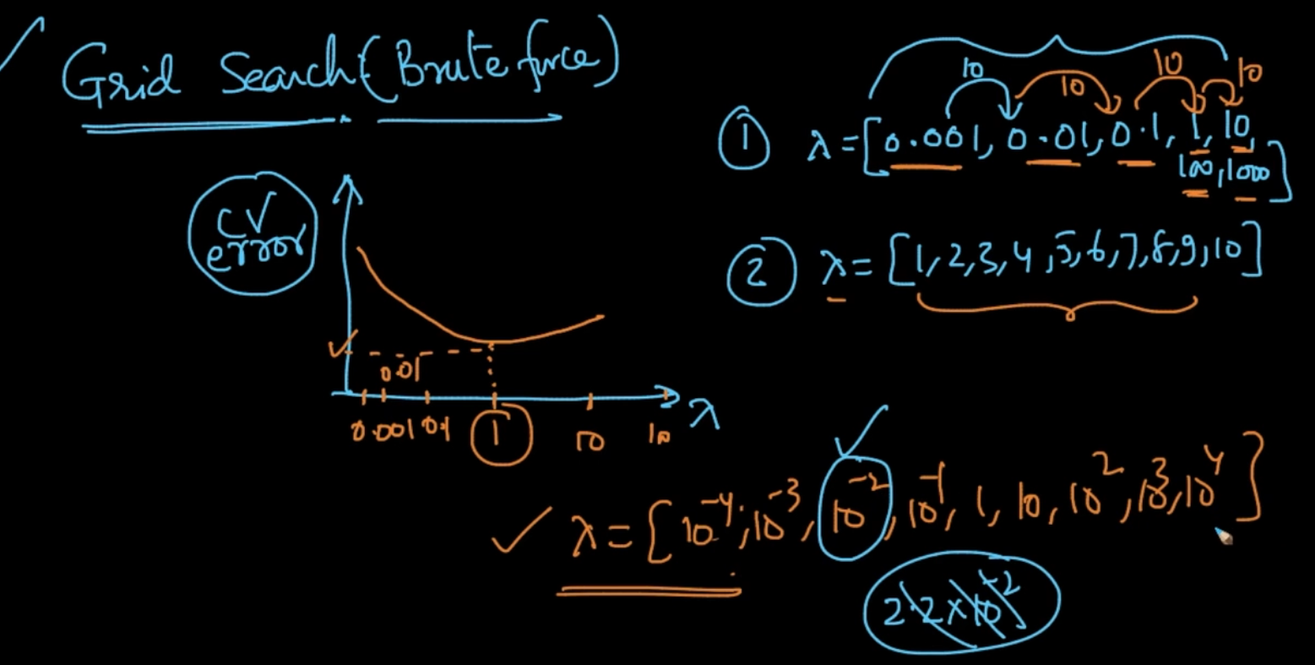

In order to tackle that real value situation of $λ$ we’ll do a Brute Force technique called Grid Search where we create a window from $λ =$ [0.001,0.01, …..100, 1000] and we plot the

CV error v/s $λ$ graph and select the best $λ$ which has lowest CV error

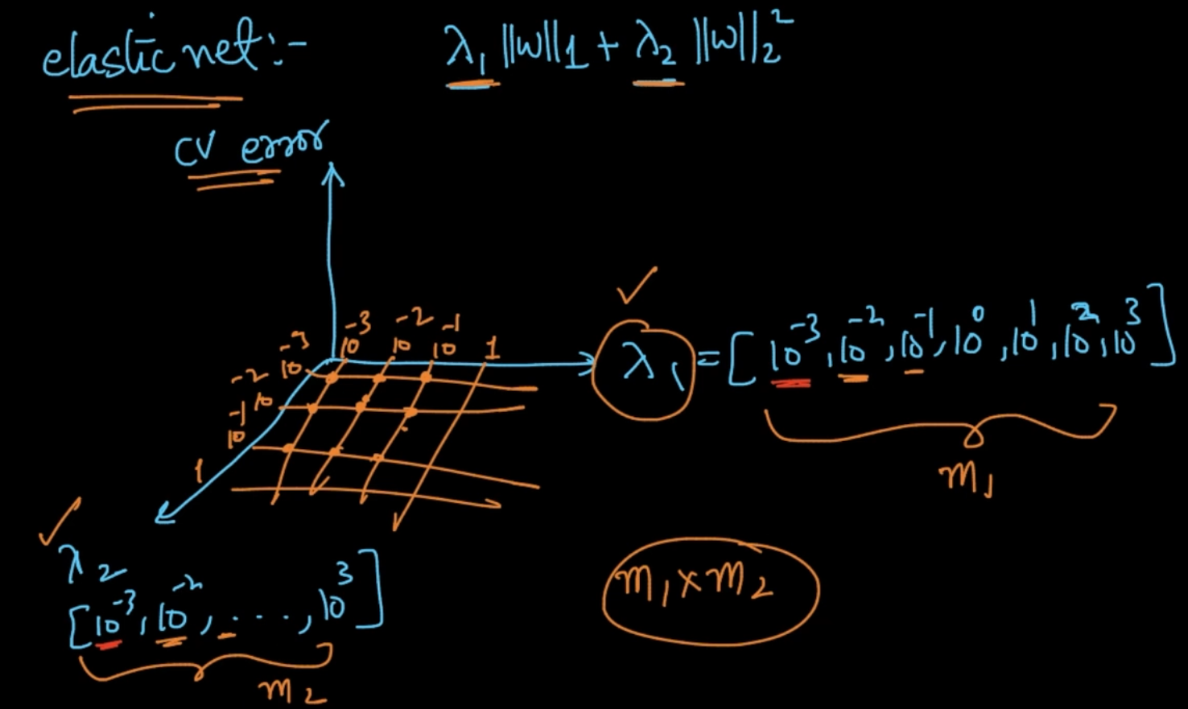

If we’ve more than one parameters, lets say above. We’ll plot the graph of $λ_{1}$ v/s $λ_{2}$ v/s

CV error to select the best $λ_{1}$, $λ_{2}$ which has lowest CV error. If $λ_{1}$ has $m_{1}$ dimensions

and $λ_{2}$ has $m_{2}$ dimensions so total calculations will be $m_{1}$ $m_{2}$

*

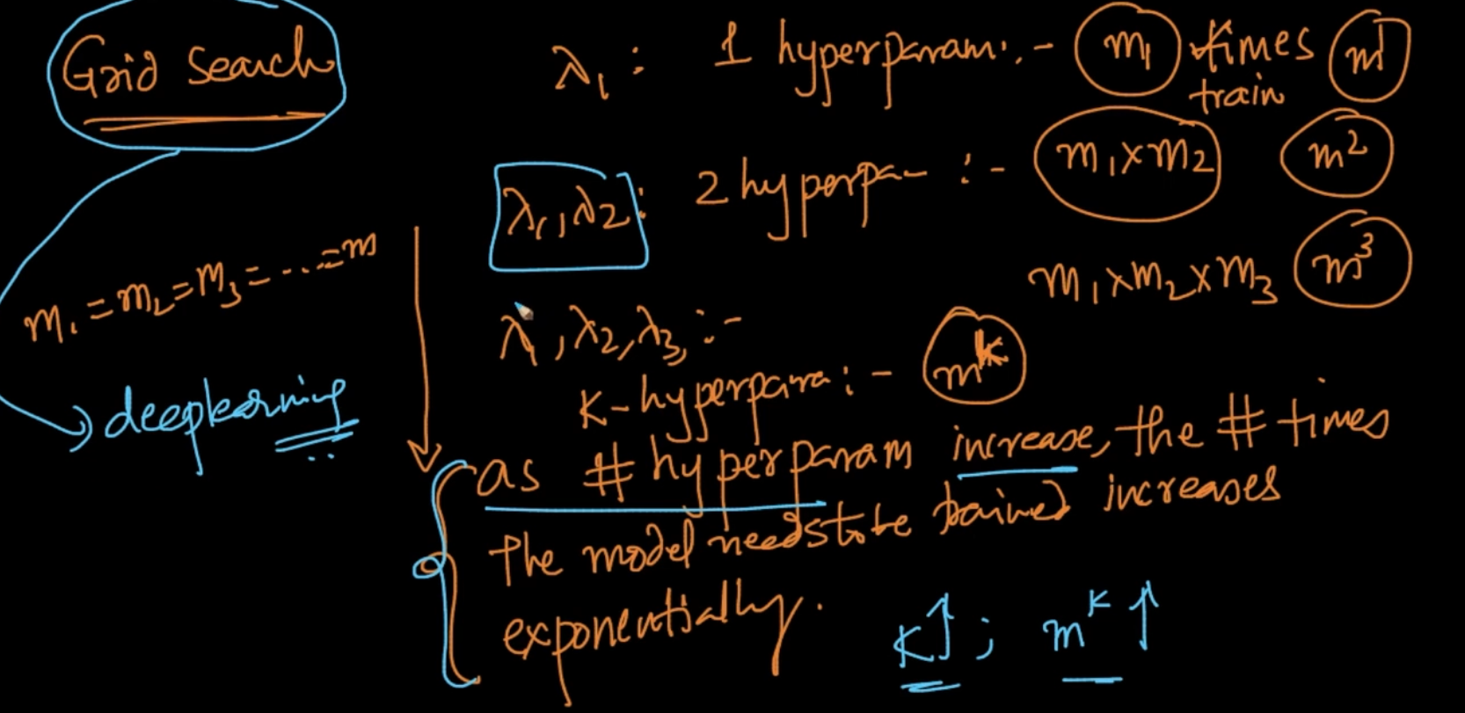

There’s one problem in Grid Search. It’s that as number of hyperparameters increase

The no. of times the model needs to be trained is increased exponentially

Ex : For 3 hyperparameters with m-dimensions has $m^{3}$ calculations.

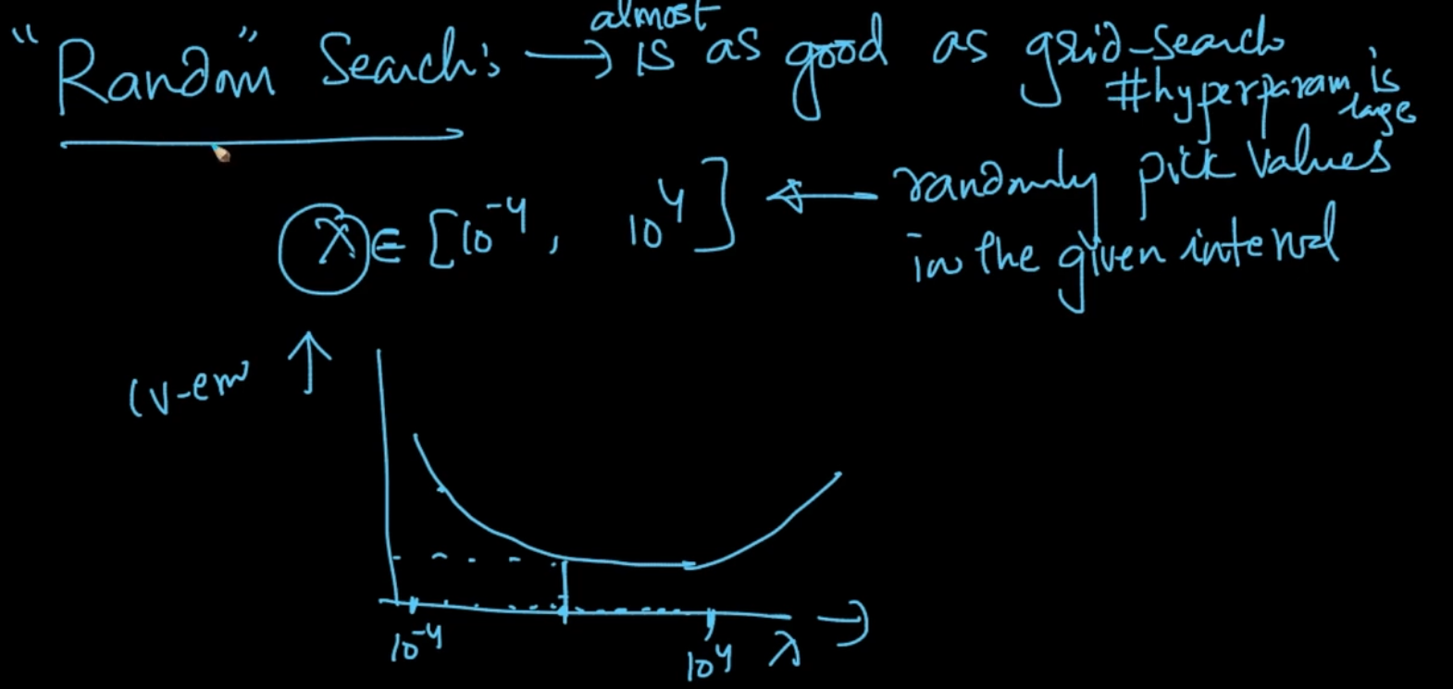

There’s another technique called Random Search in which wee select an interval and from that interval we randomly pick values and get the value of $λ$ with the lowest CV error. It’s said that it’s as good as Grid search . Used when hyperparameters are large

# **COLUMN / FEATURE STANDARDIZATION**

We are performing Column standardization by mean-centering and scaling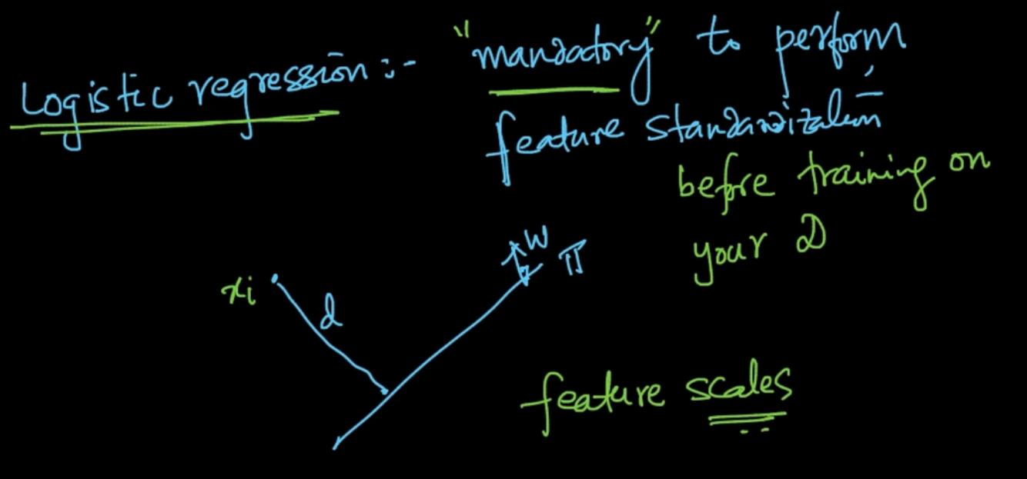

In Logistic Regression, it’s mandatory to perform Column Standardization because if two features are at different scales then it can create problems as distances can be affected by scales

# **FEATURE IMPORTANCE AND FEATURE INTERPRETABILITY**

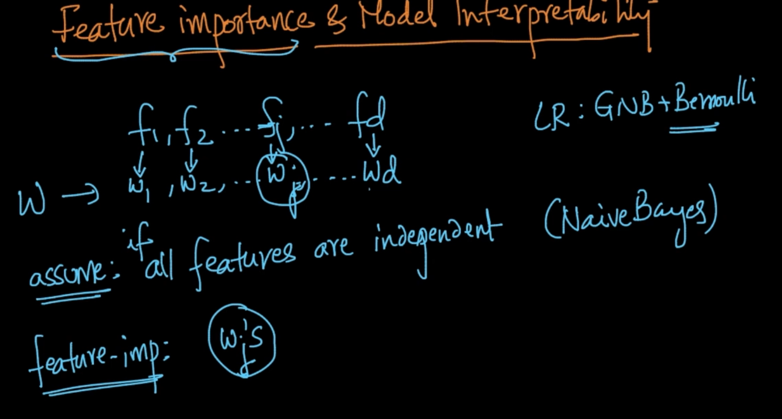

We can decide the important features by using their corresponding w’s

Note- We assume here that all features are independent just like in Naive Bayes

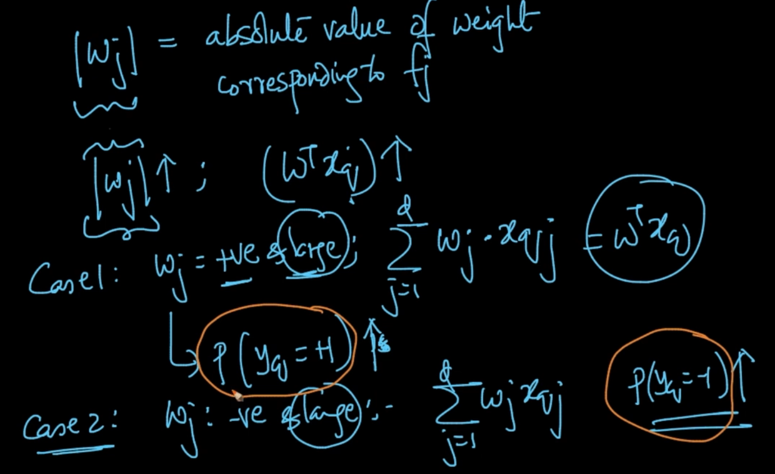

Feature importance of feature $f_{j}$ is dependent on absolute value corresponding weight vector $w_{j}$. If || is large and positive .It’ll also contribute to $w^{T}x_{q}$ therefore P($y_{q}$ = +1) is also increased. Same analogy for case 2

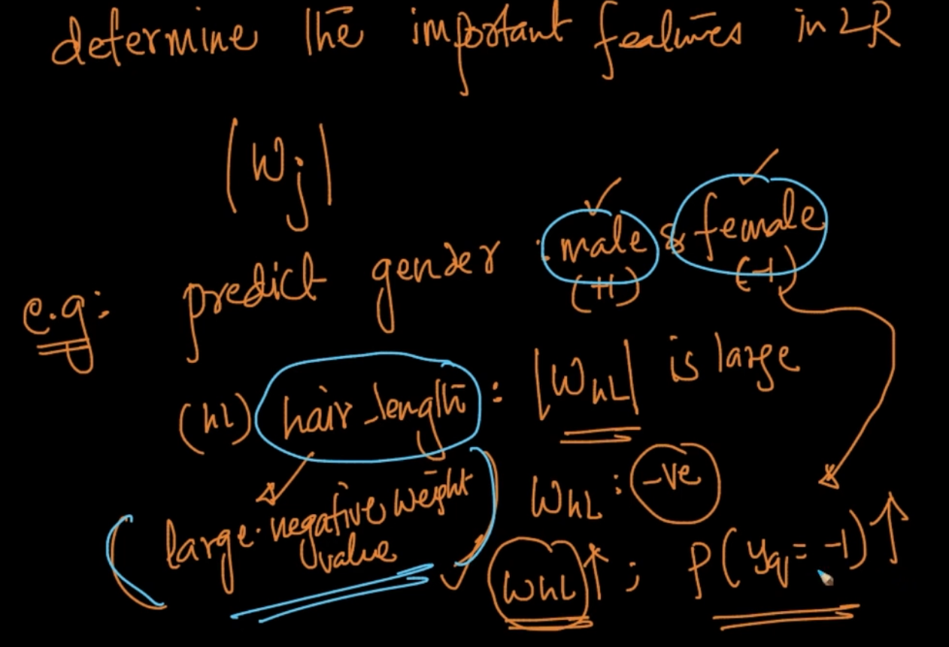

E.x: If we are predicting gender : Male = +1 and Female = -1 and we’ve a feature Hair Length(hL) and if || is large and hair_length has a large negative weight value because as $W_{hL}$ increases P($y_{q}$ = -1) also increases so it’s an important feature to classify male and female

If we are taking height as feature , weight $W_{h}$: =ve but medium positive not large positive because if we plot the distributions between male and female hL has greater seperatibility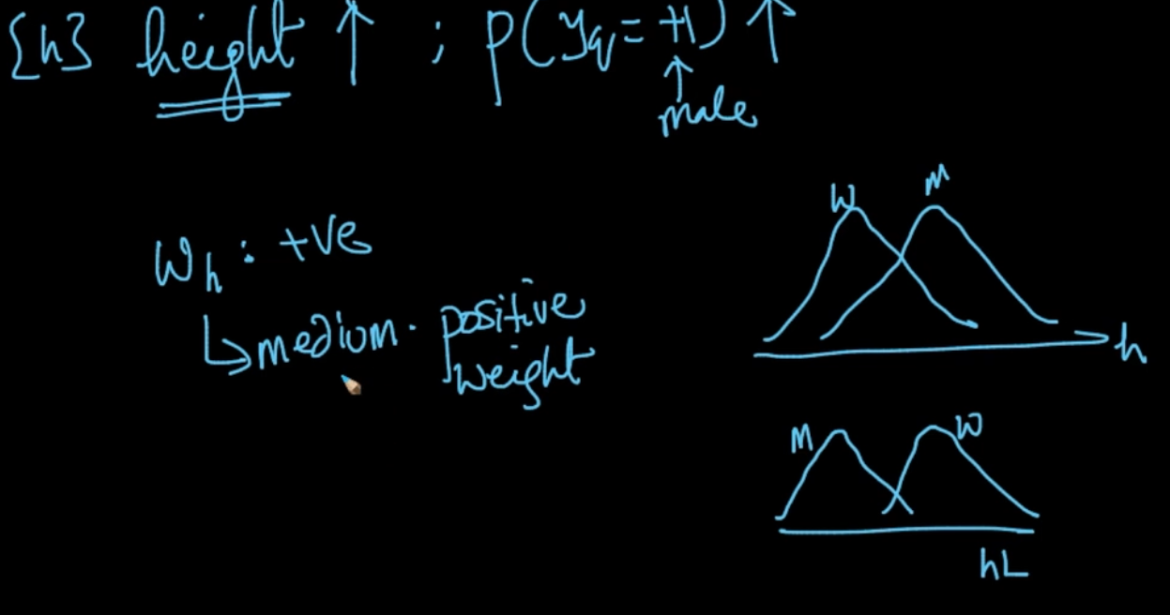

But height doesn’t have that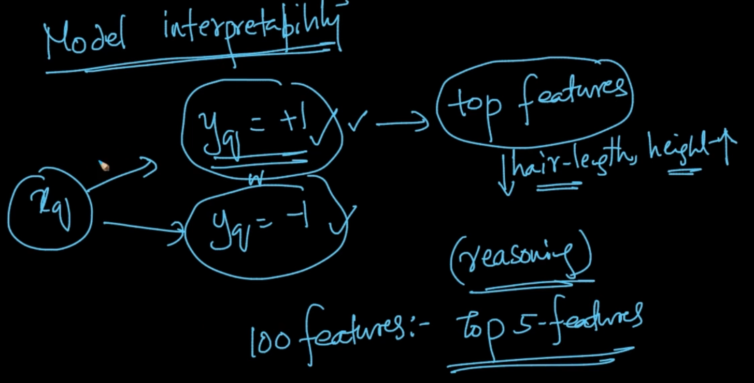

It also gives us Model Interpretability because if hair-length is low and height is high then we can say that $y_{q}$ = +1 saying that it’s a male. So we select the top features from the absolute value of the corresponding w. If they are large then that feature is important

# **COLLINEARITY OF FEATURES**

Features $f_{i}$, $f_{j}$ are collinear if $f_{i}$ = $αf_{j}$ + $β$ where $α$& $β$ are constants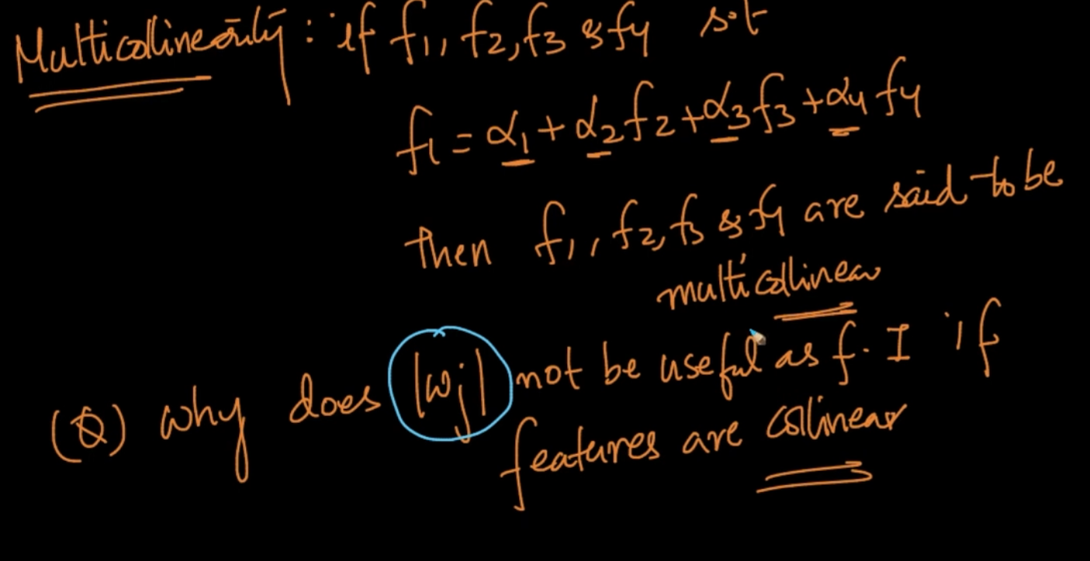

We’ll see that || for a feature $f_{j}$ is not as useful for feature importance if features are collinear

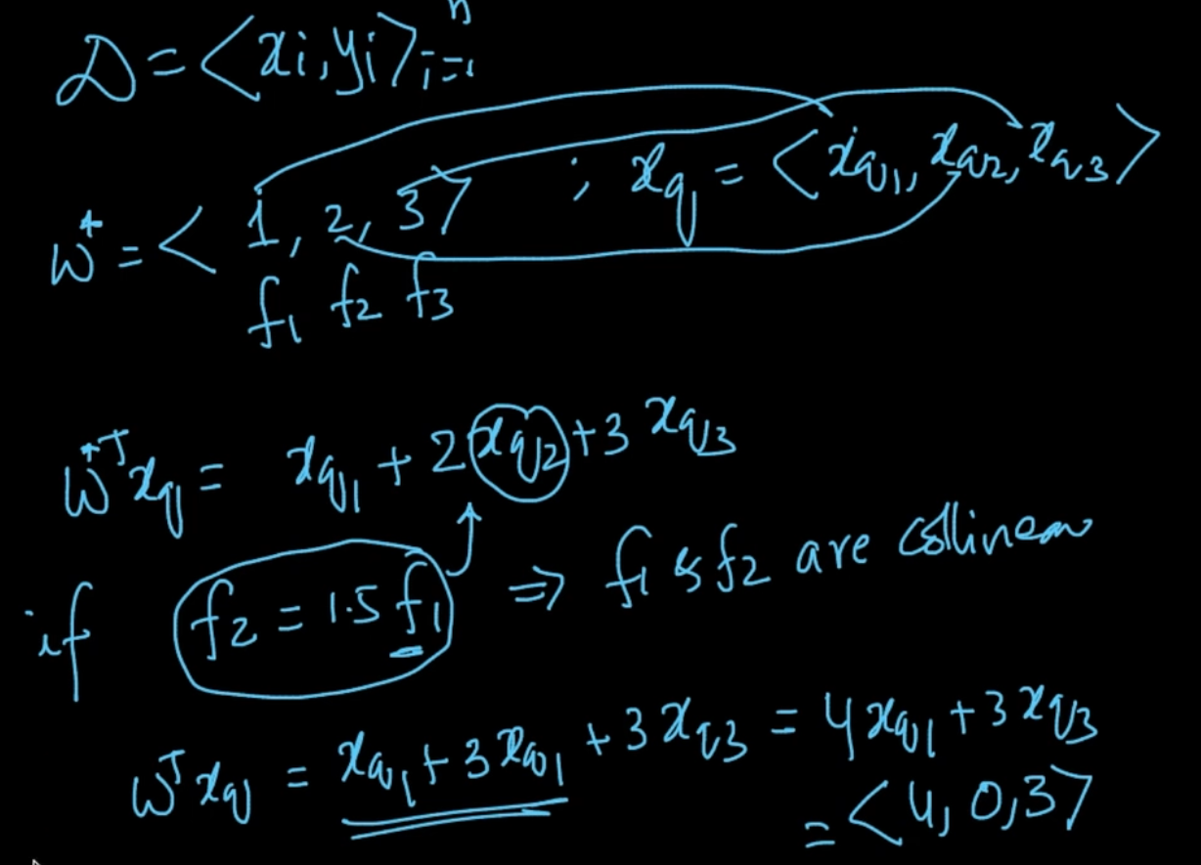

Our weight - vector $w^{*}$ = <1, 2, 3> here but $f_{2}$ = 1.5 $f_{1}$ therefore they are collinear so our weight vector will get converted to $\underline{w}$ =<4, 0, 3>

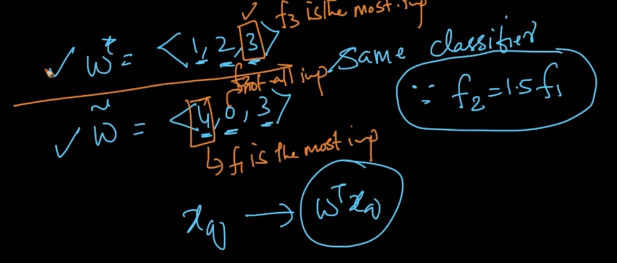

In $w^{*}$, $f_{3}$ is the most important feature as it has the highest absolute weight vector value

But in $\underline{w}$ $f_{1}$ is the most important feature and both w’s give the same classifier since features are collinear

NOTE - If features are collinear then weight vectors can change arbitrarily so |w| cannot be be used for Feature Importance as seen from the example above

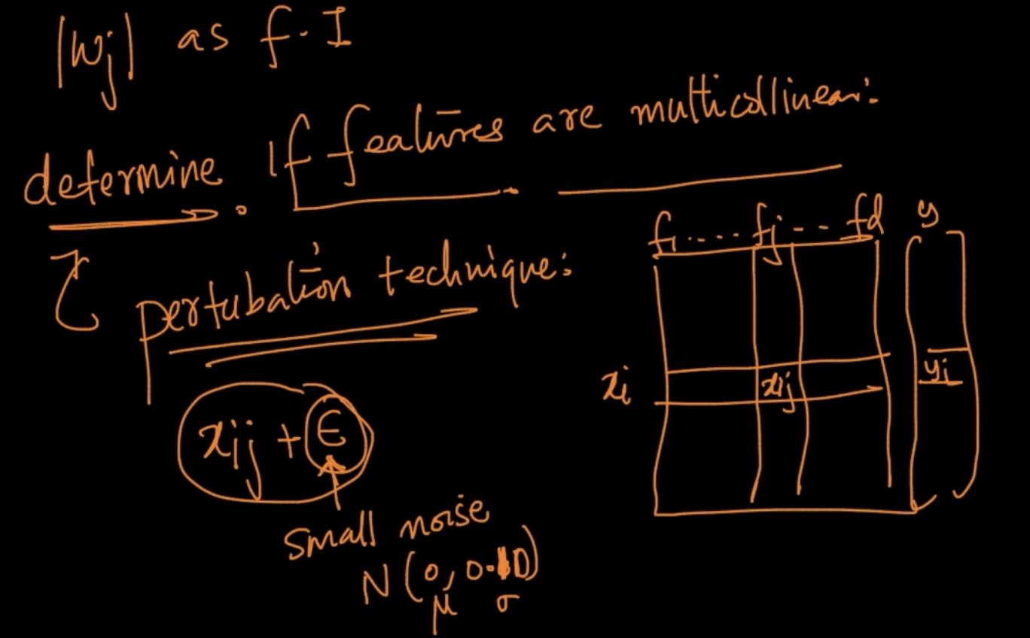

To determine the features are multicollinear we use pertubation technique in which we add a small noise $ϵ$ to the data point $x_{ij}$ which has small variance

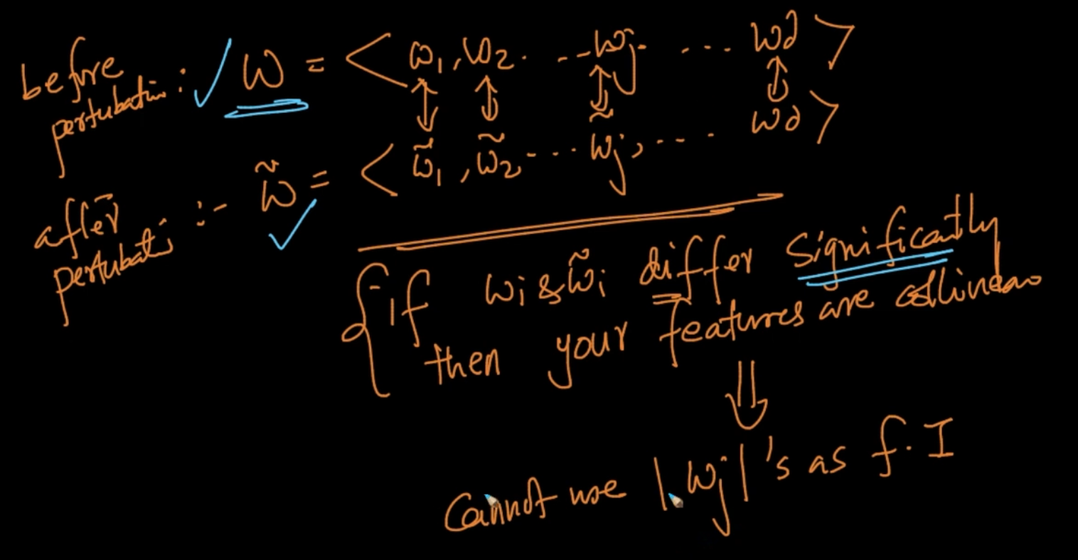

So we compare the weight vectors before and after the perturbation technique. If the difference is very significant then the features are collinear. So || cannot be used

# **TRAIN & RUNTIME SPACE COMPLEXITY**

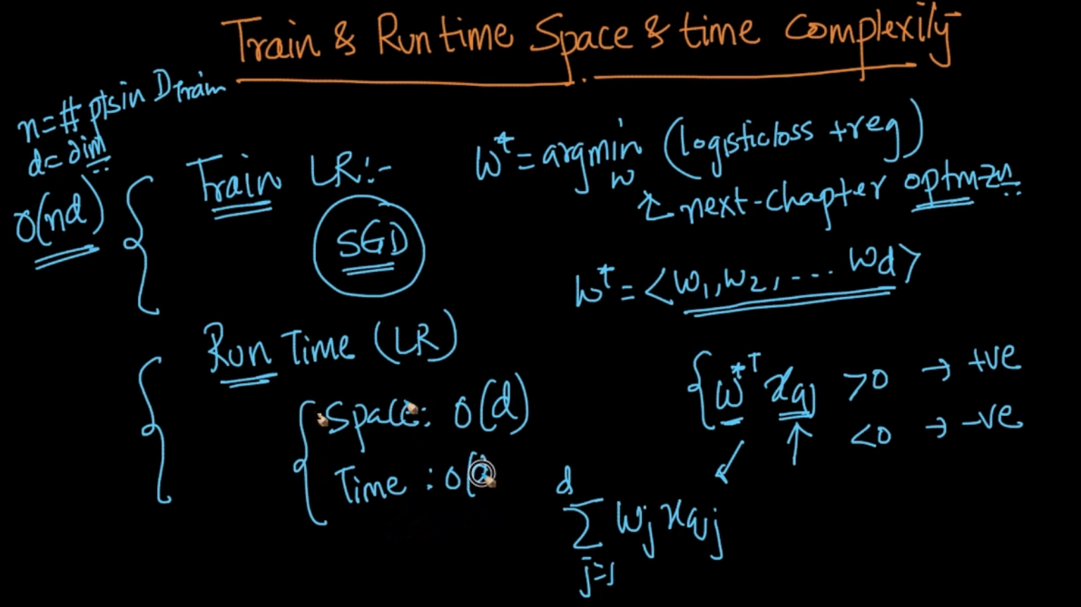

In Runtime, we need to only store the optimal $w^{*}$, if it has d- dimensions then it’s Space complexity will be O(d) because $x_{q}$ is given at run time. It’s time complexity will also be O(d) as only d - multiplications and d-1 addition

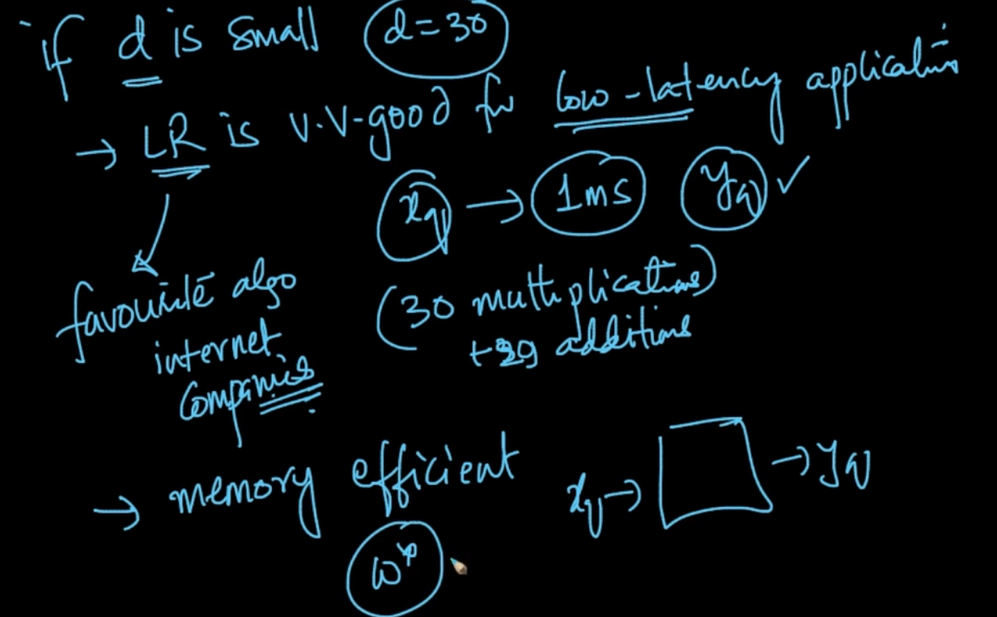

If d is small, Logistic Regression is very good for low latency. Ex: If d = 30 then 30 multiplications and 29 additions. It’s also memory efficient as only need to store $w^{*}$

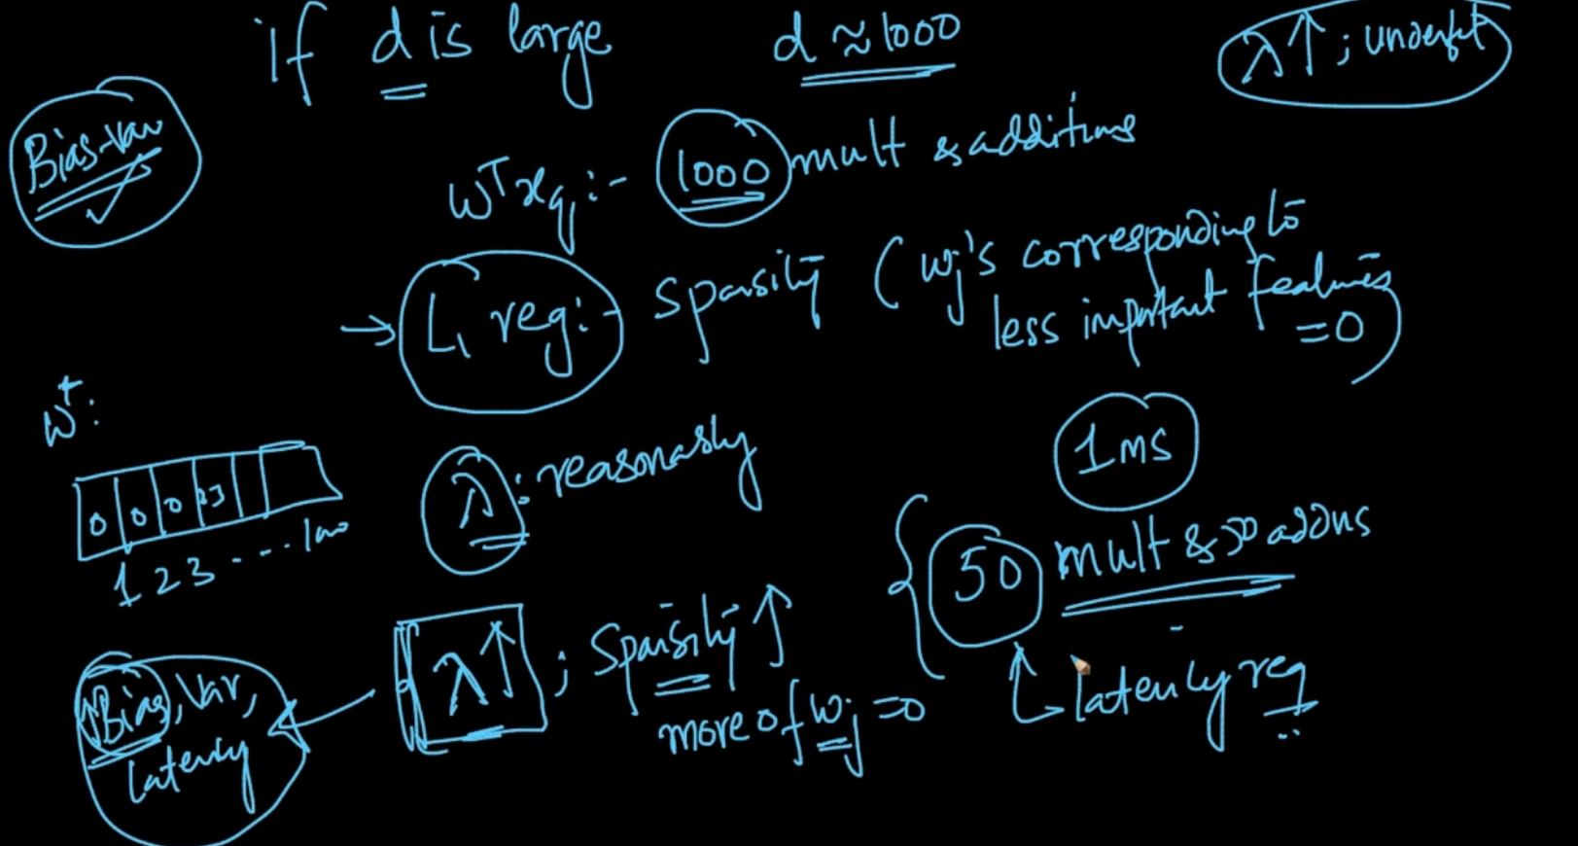

If d is large then there’ll be slightly more time as 1000 multiplications and additions but we know that $L_{1}$ regularization we can create sparsity i.e $w_{j}$ corresponding to less important features = 0. If the required latency is only achieved by 50 multiplications and 50 additions per microsecond then we increase the $λ$ as increasing the $λ$ increases sparsity but it means also increase in bias means underfitting . So, we need to find the reasonable $λ$

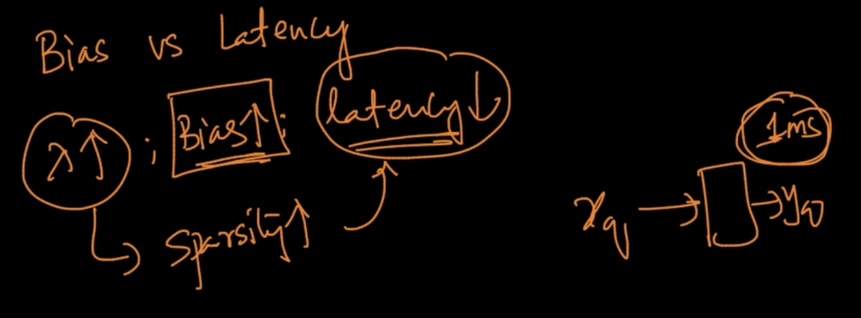

So there’s a tradeoff we do between Bias and Latency that we’ve to do to achieve our goals.Logistic Regression one of the most popular algorithm since it has low Latency

# **REAL WORLD CASES**

Assumption :- Our data is linearly separable. Feature Importance: || i.e it depends on the absolute value of the weight vector i’th dimension but our features are not multi-collinear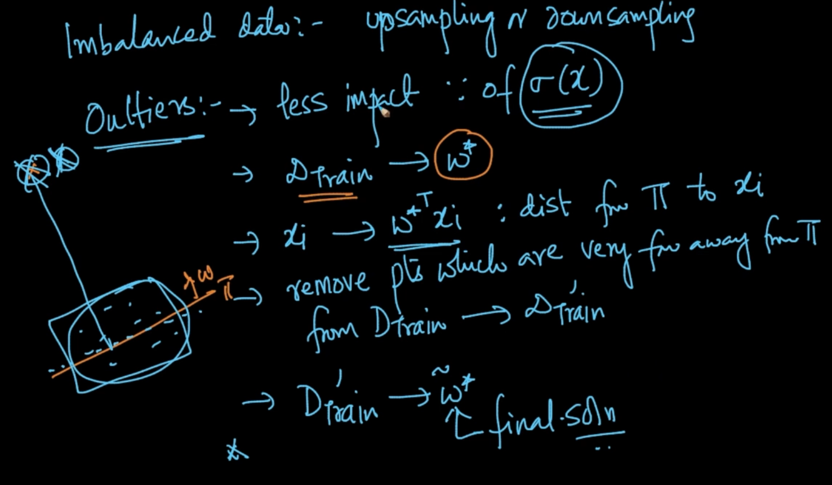

If we’ve outliers then also it has less impact because of sigmoid function. We’ll get the optimal $w^{*}$. If the data point $x_{i}$ has great distance from hyper-plane $π$ then we remove that data point and then train again . Our new $\underline{w*}$ is our final solution

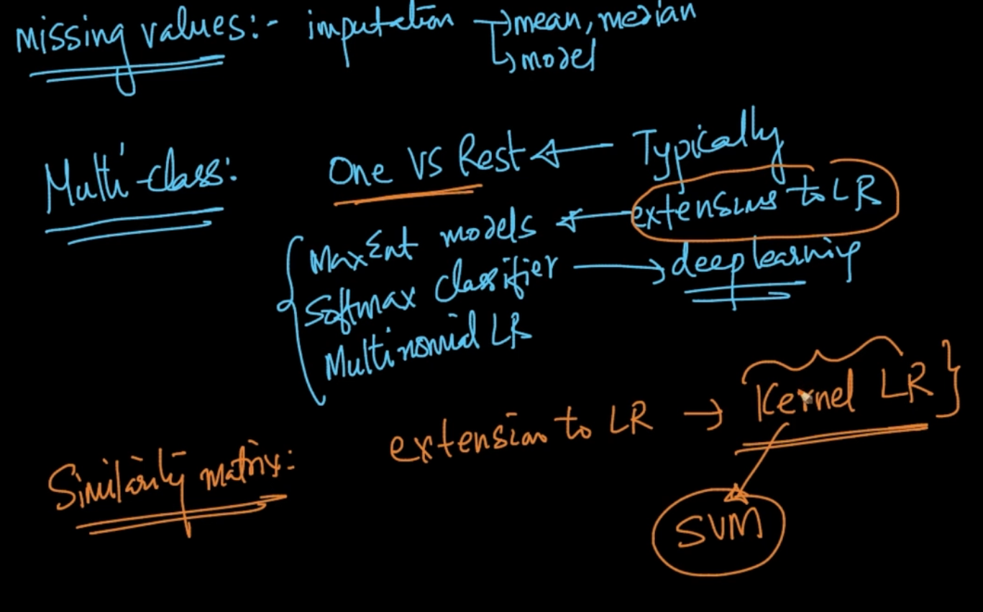

Other cases where Logistic Regression can be applied

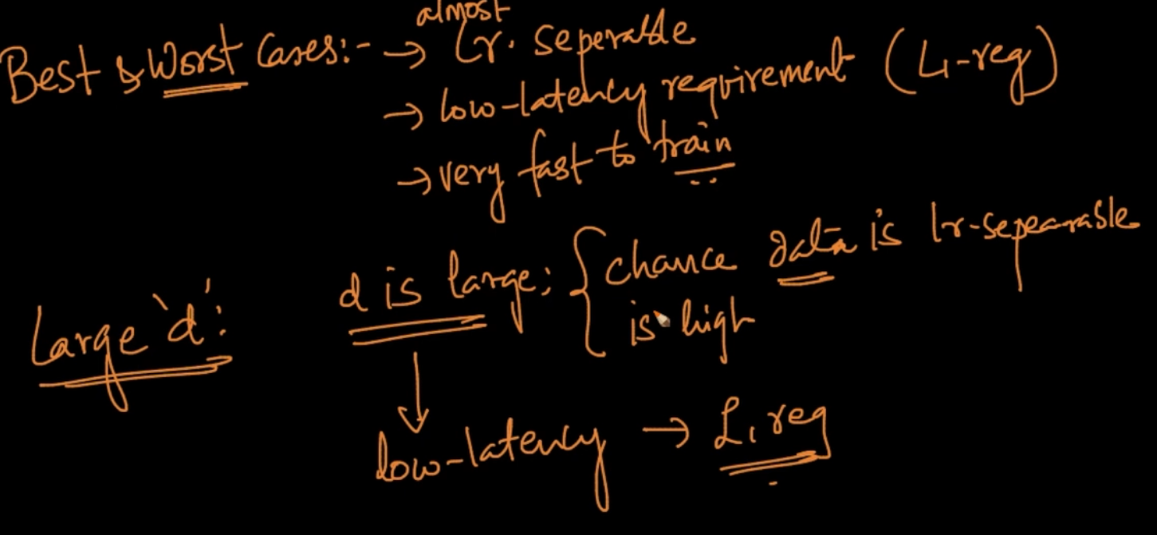

We’ve seen the best cases above but even if ‘d’ is large then chance that data is linearly separable is high and if requirement is low latency then L1-regularization

# **FEATURE ENGINEERING**

We apply Logistic to the data which is Linearly separable but in the above data Drawing a plane/line cannot separate +ve and -ve points. So, the question is can we apply LR to separate the classes?

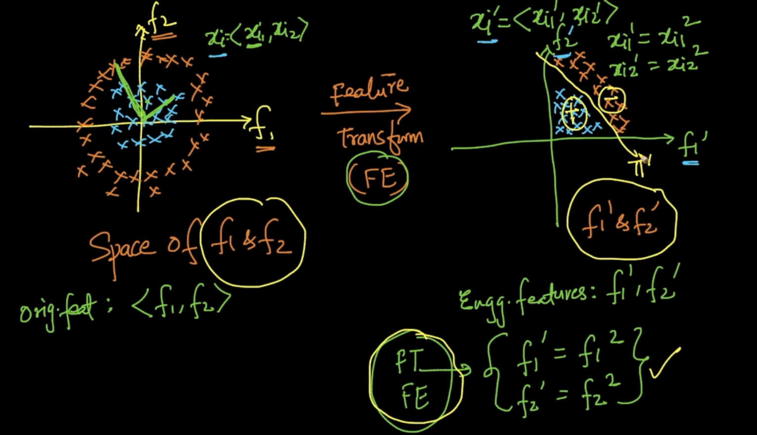

We are applying Feature Transformation by taking the features to a different space ${f'}_{1}$ and $f_{2}^{'}$. Here, $f_{1}^{'}$ = $f_{1}^{2 }$ and $f_{2}^{'}$ = $f_{2}^{2 }$. As the distance of -ve point is more than +ve points they’ll be clustered far away as seen but now they can be separated with a hyper-plane $π$. So Logistic Regression definitely works here

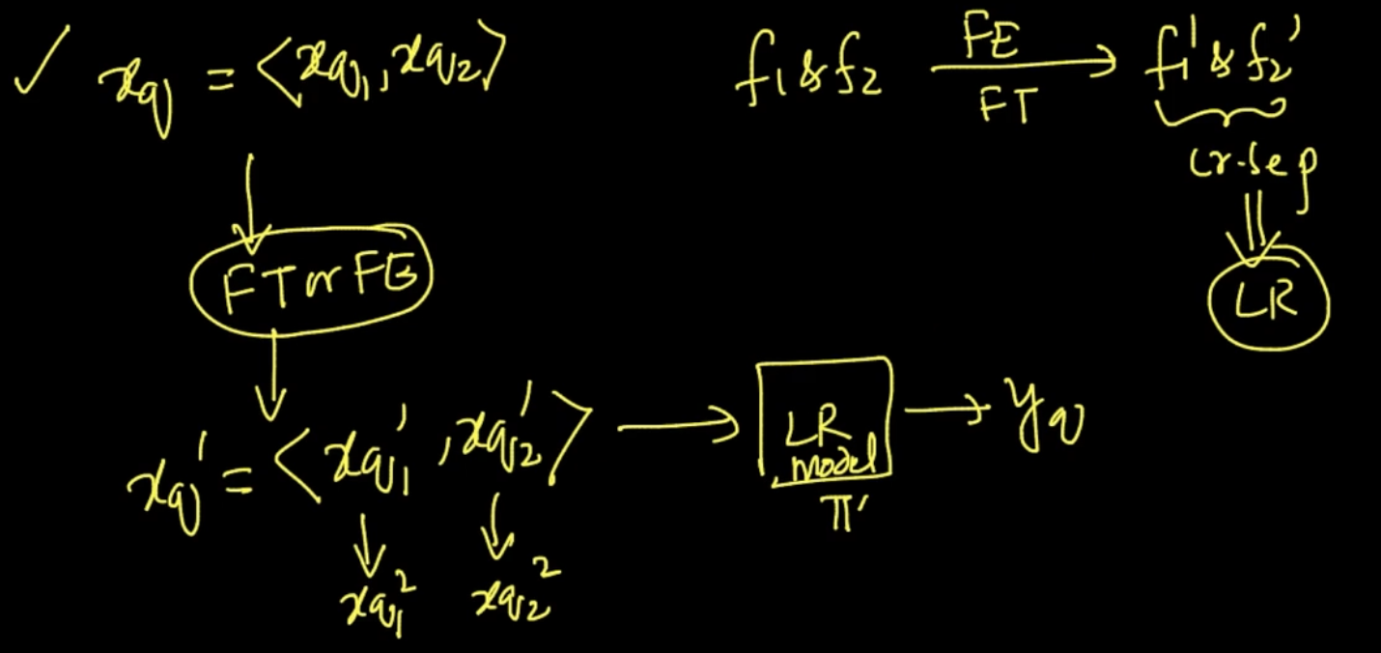

Feature Engineering is done on the features taking them to a different space which are linearly separable and Logistic Regression can be applied there

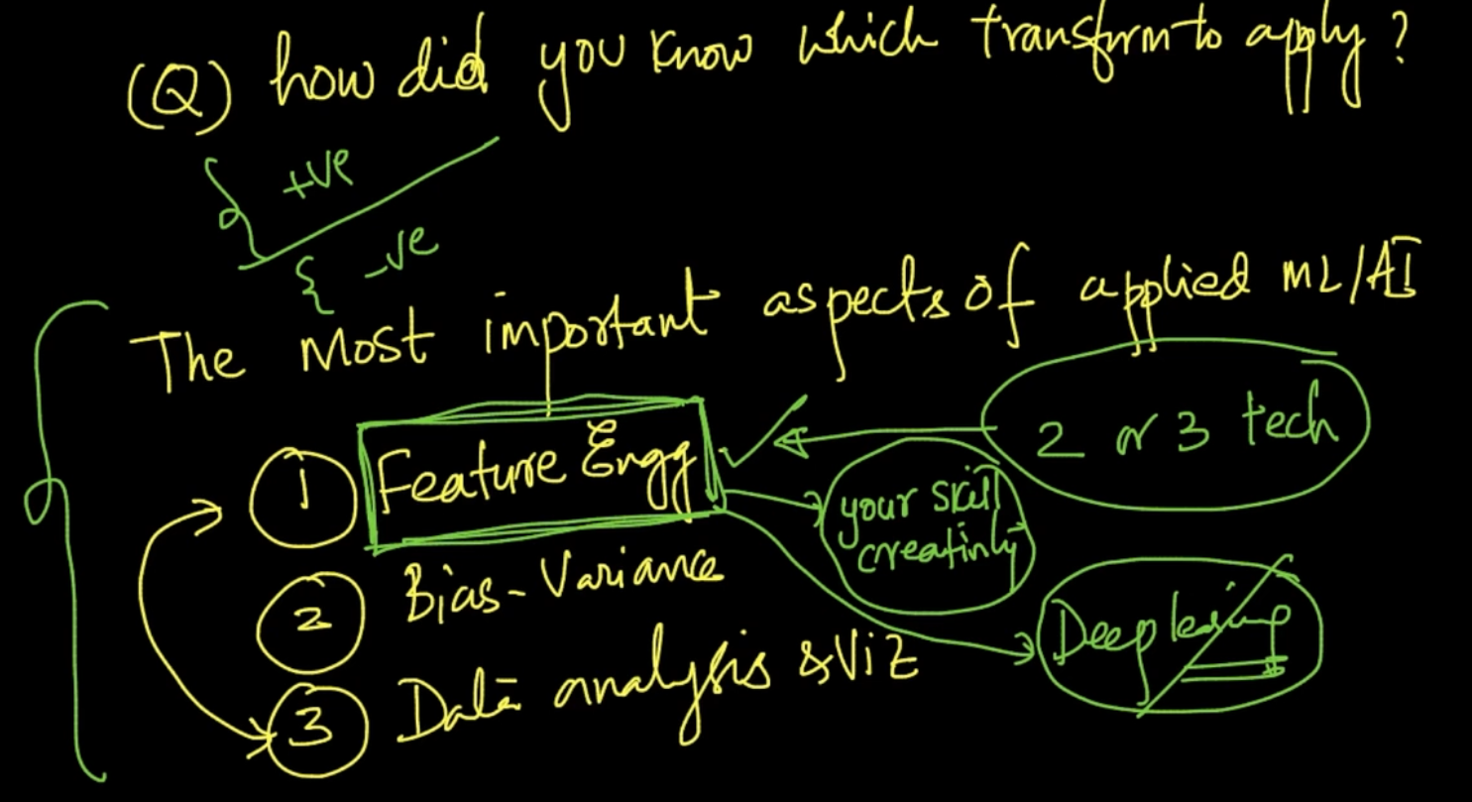

Feature Engineering is the important aspect of applied Machine Learning

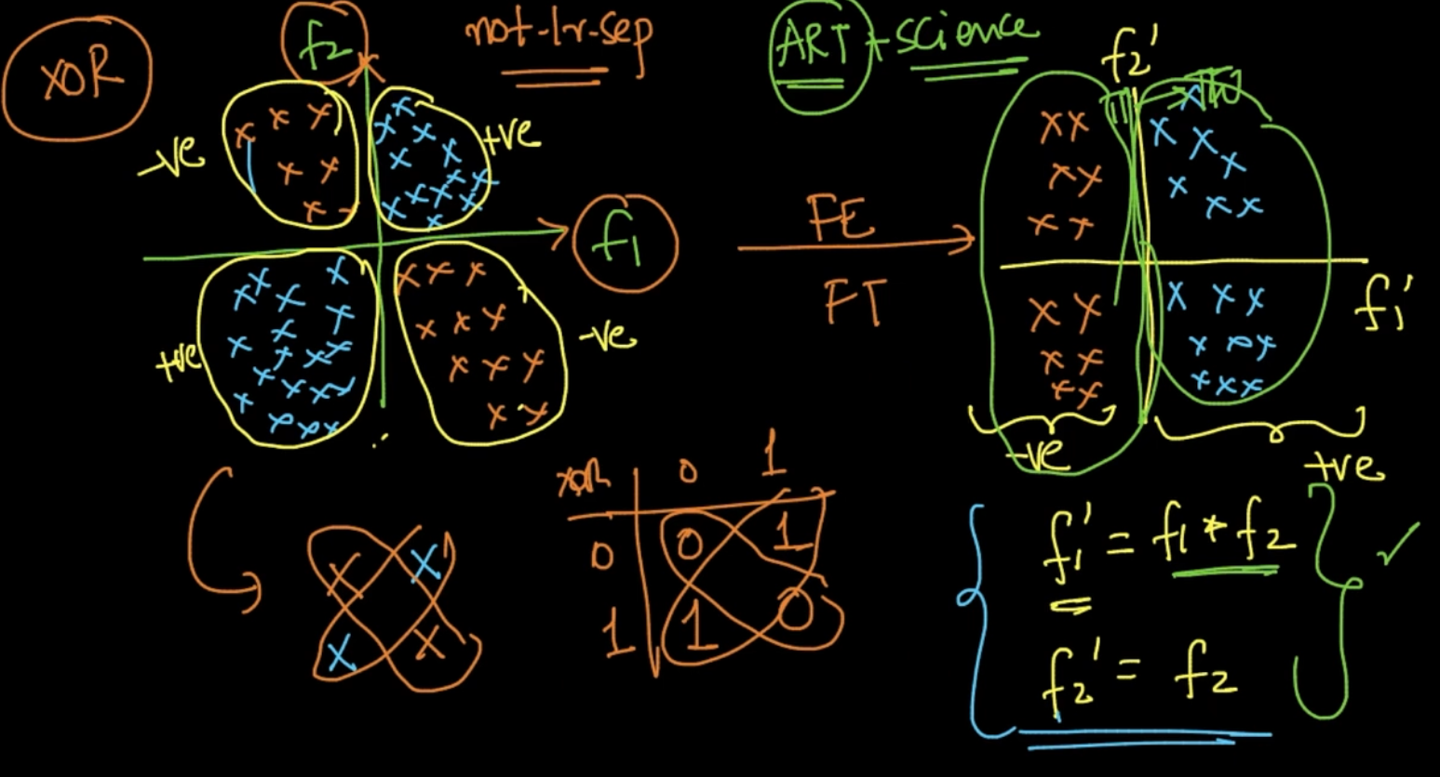

This is XOR dataset. To apply feature engineering , f1’ = f1 * f2, f2’ = f2. When we do this all the blue points become +ve and the orange points become -ve so can be linearly separated

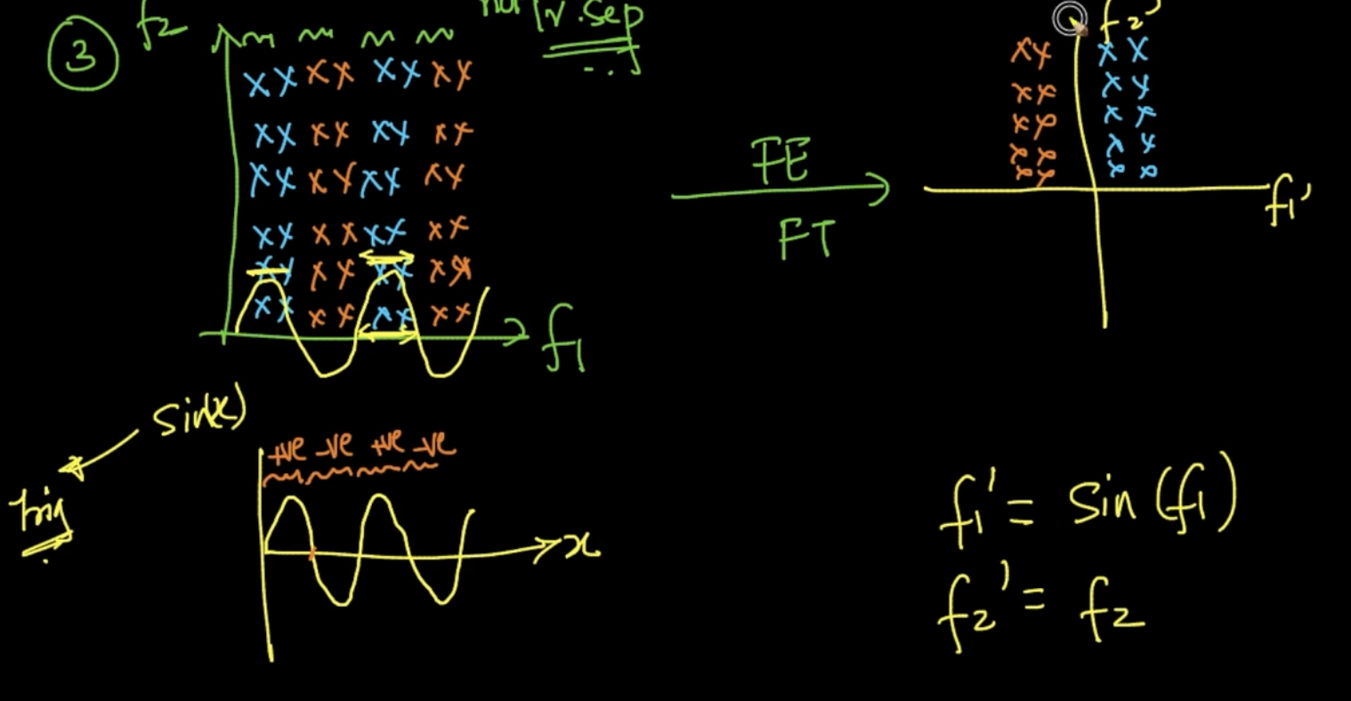

Here, feature engineering is done by applying sin() function as we can see all the blue points are in positive region of sinusoidal wave and orange points in negative region . So, it can be separated after that as seen above

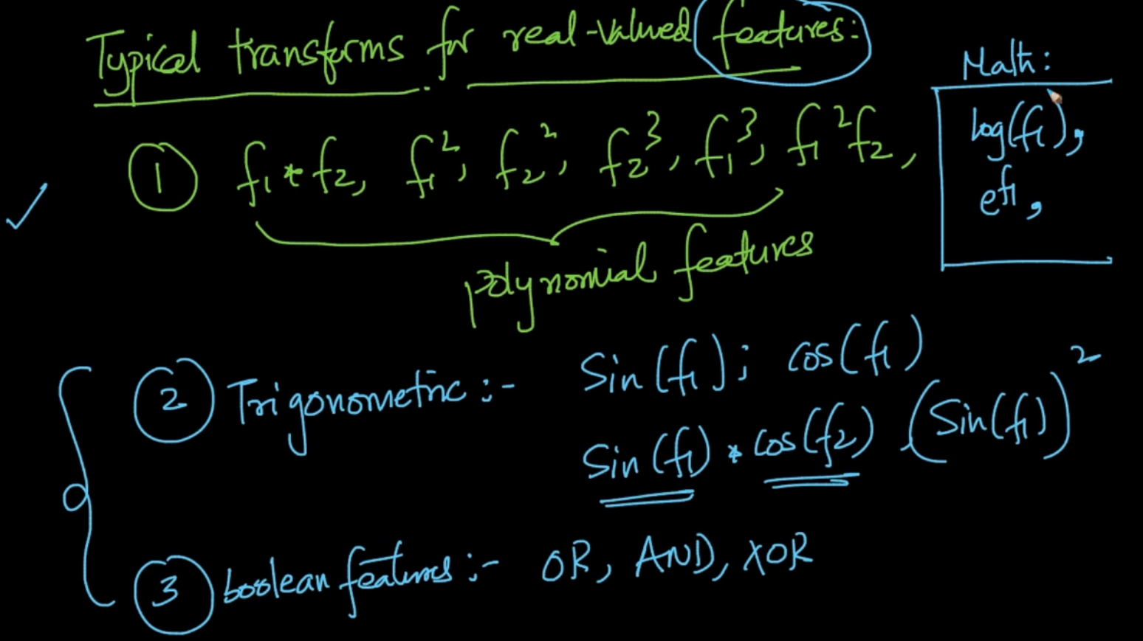

These are the typical transformation methods applied in Feature Engineering.